**TABLE OF CONTENTS**

|  |  |
| --- | --- |
| **DESCRIPTION** |  |
|  |  |
| **ABOUT US** |  |
|  |  |
| **COMPANY STRUCTURE** |  |
|  |  |
| **LICENSES** |  |
|  |  |
| **PRODUCT LINES** |  |
|  |  |
| **SUPPLIERS LIST** |  |
|  |  |
| **PROJECT PORTFOLIO** |  |
|  |  |
| **SERVICES & PORTFOLIO** |  |
|  |  |
| **MAJOR ONGOING PROJECTS** |  |
|  |  |
| **MAJOR COMPLETED PROJECTS** |  |
|  |  |
| **MAJOR CLIENTS** |  |
|  |  |
| **ORGANIZATIONAL CHART** |  |
|  |  |
| **LIST OF EMPLOYEES** |  |
|  |  |
| **QUALITY MANUAL** |  |
|  |  |
| **SAFETY MANUAL** |  |
|  |  |
|  |  |

**About Us**

|  |
| --- |
|  |

*Nazo Building Materials Trading Est., located in Sharjah, is a leading supplier of modern, high quality porcelain and ceramic tiles. Our tiles range from the classical series to the contemporary series in order to satisfy the diverse market needs. Nazo Building Materials Trading Est. was precisely formed to address this growing taste and demands in the region. As the face of U.A.E. is rapidly changing, we continue to be on the cutting edge in product selection and service.*

*We have taken great care to partner and associate with leading manufacturers of ceramic tiles from Italy, Spain, South America and the Far East to meet the demands of this constantly changing market. Our aim is to provide excellent quality products with imaginative designs to our customers at competitive prices.*

*Encouraged by tremendous growth of the property market and the real estate in the region, we at Nazo Building Materials Trading Est. are equipped to meet the growing demands for ceramic products. Today, our vast experience in the ceramic industry has helped us to undertake many projects and provide artistic designs to meet the sophisticated demands of the most of the leading architects, designers, consultant and customers.*

*Over 3 decades, Nazo Building Materials Trading Est. has maintained an aggressive growth rhythm, giving its customers a product of high quality, with the best designs at competitive prices. Whether you are looking to furnish your villa, apartment or development, visit us at Nazo Building Materials Trading Est. Our staff will guide you through the many choices based on your individual need, budget and style.*

**Company Structure**

|  |
| --- |
|  |

BRANCH

NAZO Building Materials Trdg. Est.

P.O. Box No. 6934,

Industrial Area No. 4, U.A.E.

Tel: 06 533 5354, Fax: 06 533 2628

BRANCH

NAZO Building Materials Trdg. Est.

P.O. Box No. 2159,

Fujairah, U.A.E.

Tel: 09 223 3385, Fax: 09 223 3386

HEAD OFFICE

NAZO Building Materials Trdg. Est.

P.O. Box No. 6934,

Al Wahdah Street, Sharjah, U.A.E.

Tel: 06 567 1221, 567 1511, Fax: 06 567 1191

Email: [nazo@emirates.net.ae](mailto:nazo@emirates.net.ae)

HEAD OFFICE

NAZO Building Materials Trdg. Est.

P.O. Box No. 6934,

Al Wahdah Street, Sharjah, U.A.E.

Tel: 06 567 1221, 567 1511, Fax: 06 567 1191

WAREHOUSE

NAZO Building Materials Trdg. Est.

(107,600 Sq. Ft.)

Plot No. 326 & 328

Industrial Area, Block No. 1

Al Jurf Area, Ajman, U.A.E.

CUTTING FACTORY

NAZO Building Materials Trdg. Est.

(21,520 Sq. St.)

Plot No. 475, Block No. 20

Al Jurf Area, Sanaya,

Ajman, U.A.E.

**Licenses**

|  |
| --- |
|  |

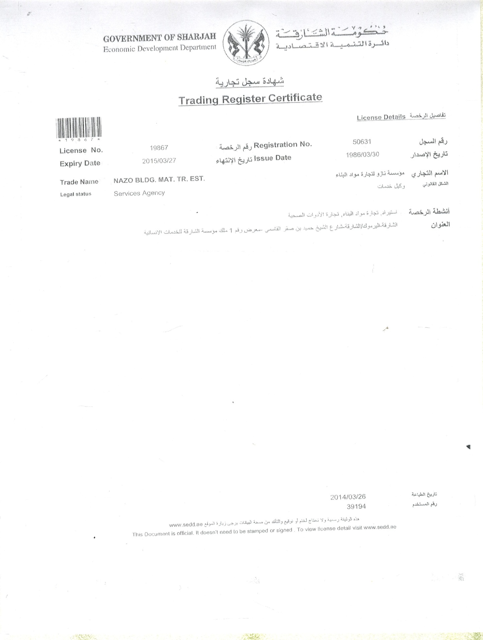

**Licenses**

|  |
| --- |
|  |

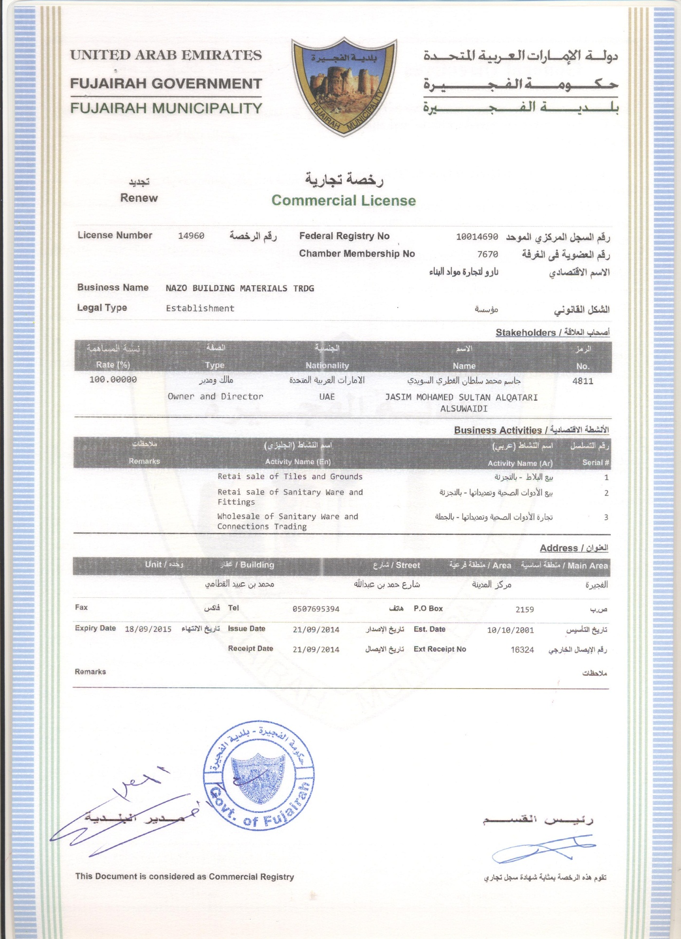

**Licenses**

|  |
| --- |
|  |

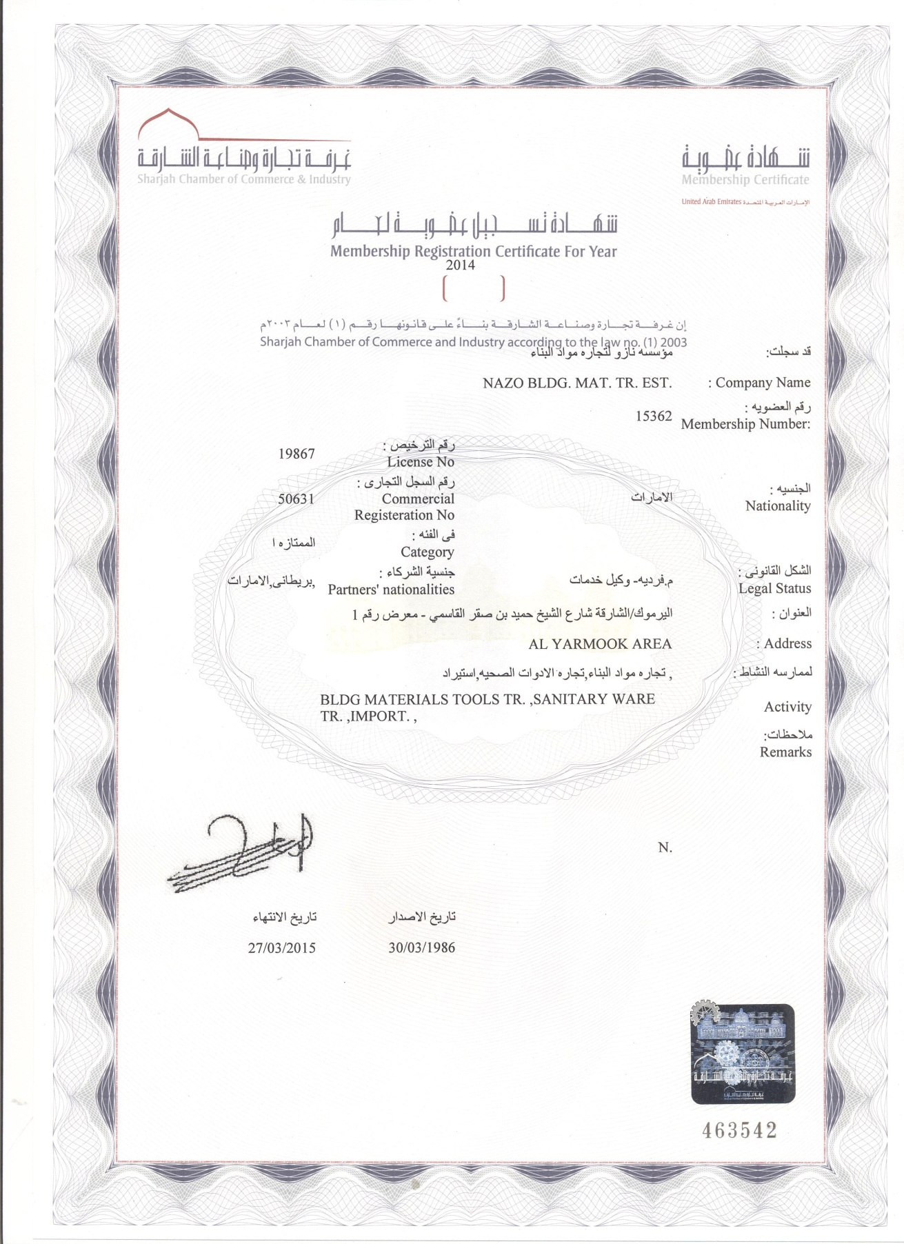

**Product Lines**

|  |
| --- |
|  |

|  |  |
| --- | --- |
| **SI No.** | **Products** |
| 1. | Porcelain Tiles |
|  |  |
| 2. | Ceramic Tile |
|  |  |
| 3. | Marble Tiles |
|  |  |
| 4. | Glass Mosaic Tiles |
|  |  |
| 5. | Porcelain Mosaic Tiles |
|  |  |
| 6. | Marble Mosaic Tiles |
|  |  |
| 7. | Customized Waterjet Design |
|  |  |
| 8. | Quartz Tiles |
|  |  |
| 9. | Marmol Tiles |
|  |  |
| 10. | Indoor / Outdoor Wall Cladding |
|  |  |
| 11. | Sanitary Mixers |
|  |  |
| 12. | Bathroom Fittings & Accessories |
|  |  |
| 13. | Jacuzzi |
|  |  |
| 14. | Bathtubs |
|  |  |
| 15. | Shower Trays & Shower Enclosures |
|  |  |
| 17. | Mirrors |
|  |  |
| 18. | Grout & Tile Cleaning Products |

**Suppliers List**

|  |
| --- |
|  |

|  |  |  |
| --- | --- | --- |
| **COUNTRY OF ORIGIN - ITALY** | | |
| **NO.** | **FACTORY** | **ADDRESS** |
| 1 | NOVABELL S.PA. Ceramiche Italiane  **C:\Users\Secretary\Desktop\SCANS\ADMIN\FACTORY LOGOS\Novabell.jpg** | Via Milino, 1 – 42010  Roteglia Di Castellarano (RE), Italy |
| 2 | CERAMICA ARIANA  C:\Users\Secretary\Desktop\SCANS\ADMIN\FACTORY LOGOS\ARIANA.bmp | Via Radici Nord, 164/166 – 42014  Castellarano (RE), Italy |
| 3 | CEDIR  C:\Users\Secretary\Desktop\SCANS\ADMIN\FACTORY LOGOS\cedir_logo_page[1].png | Ceramiche Di Romagna S.P.A.  Via Emilia Ponente, 2070 – 48014  Castelbolognese (RA), Italy |
| 4 | FAP CERAMICHE  C:\Users\Secretary\Desktop\SCANS\ADMIN\FACTORY LOGOS\FAP.jpg | Via Ghiarola Nouva, 44  41042 Fiorano Modenese (MO), Italy |

**Suppliers List**

|  |
| --- |
|  |

|  |  |  |
| --- | --- | --- |
| 5 | CERAMICHE COLLI DI SASSUOLO S.P.A.  [http://t3.gstatic.com/images?q=tbn:ANd9GcRLswGysErnHZzPqJ5pQx52JMyR6O6-ns4AukN35sl1ucz-SkDPhY06xVY](http://www.google.com/imgres?imgurl=http://homepage.tinet.ie/~023tiles/collilogo.gif&imgrefurl=http://homepage.tinet.ie/~023tiles/floorimages.html&usg=__xMNLTi8jcx12IJ_v1dNmhxPNVLo=&h=220&w=210&sz=9&hl=en&start=7&zoom=1&tbnid=UBhXLAzELu4kHM:&tbnh=107&tbnw=102&ei=b8qXUNjOEs6GswaBjoEQ&prev=/search?q=CERAMICA+COLLI+LOGOS&um=1&hl=en&biw=1562&bih=787&noj=1&tbm=isch&um=1&itbs=1) | Via Viazza 1 Tronco, 42 – 41042  Fiorano Modenese (MO), Italy |
| 6 | ALFALUX CERAMICHE  C:\Users\Secretary\Desktop\SCANS\ADMIN\FACTORY LOGOS\logo[1].png | Via Della Repubblica, 16 - 42010  Roteglia Di Castellarano (RE) Italy |
| 7 | CERAMICA DI TREVISO SRL  C:\Users\Secretary\Desktop\SCANS\ADMIN\FACTORY LOGOS\logo-ceramica[1].jpg | Via Amendola 1 – 31050 Villorbo, Italy |
| 8 | CVS ITALIA S.R.L.  C:\Users\Secretary\Desktop\SCANS\ADMIN\FACTORY LOGOS\imagesCABXI25H.jpg | Via Gregorio Vii, 508  00165 Roma, Italy |

**Suppliers List**

|  |
| --- |
|  |

|  |  |  |
| --- | --- | --- |
| 9 | CERAMICHE BRENNERO S.P.A.  C:\Users\Secretary\Desktop\SCANS\ADMIN\FACTORY LOGOS\brennero-logo1[1].jpg | Strada Pavesa, 9 – 46020  Bondeno Di Gonzaga (MN), Italy |
| 10 | DADO CERAMICA S.R.L.  C:\Users\Secretary\Desktop\SCANS\ADMIN\FACTORY LOGOS\dado.png | Via Sicilia 21, 40010 S. Matteo Della Decima, Bologna, Italy |
| 11 | ABK GROUP  C:\Users\Secretary\Desktop\SCANS\ADMIN\FACTORY LOGOS\ABK GROUP.png | Via Toscana, 24-28 – 41049  Sassuolo (MO), Italy |
| 12 | KERASAN SRL  C:\Users\Secretary\Desktop\SCANS\ADMIN\FACTORY LOGOS\KERASAN.png | 01033 Civita Castellana (VT), Italy |

**Suppliers List**

|  |
| --- |
|  |

|  |  |  |
| --- | --- | --- |
| 13 | BRANCHETTI SRL  C:\Users\Secretary\Desktop\SCANS\ADMIN\FACTORY LOGOS\BRANCHETTI.png | Via Socini 4-42029 Masone Reggio Emilia (RE), Italy |
| 14 | RUBINETTERIA REITANO  C:\Users\Secretary\Desktop\SCANS\ADMIN\FACTORY LOGOS\REITANO.png | Via Sndro Pertini, 3  28024 Gozzano, Italy |
| **COUNTRY OF ORIGIN – SPAIN** | | |
| 1 | AZTECA CERAMICA S.L.  C:\Users\Secretary\Desktop\SCANS\ADMIN\FACTORY LOGOS\logo1[1].png | Ctra. Castellon Alcora, Km 19.7 Apdo Correos 15 – 12210 Alcora, Castellon, España |
| 2 | CERAMICAS APARICI  C:\Users\Secretary\Desktop\SCANS\ADMIN\FACTORY LOGOS\aparici.bmp | Ctra. Castellon-Alcora Km 12 – 12110 Alcora (Castellon), Spain |

**Suppliers List**

|  |
| --- |
|  |

|  |  |  |
| --- | --- | --- |
| 3 | INCEAZAHAR CERAMICA Y GRES  C:\Users\Secretary\Desktop\SCANS\ADMIN\FACTORY LOGOS\AZAHAR.png | Partida Santa, S/N Apartado 122 – 12110 Alcora (Castellon), Spain |
| 4 | GRES CID  C:\Users\Secretary\Desktop\SCANS\ADMIN\FACTORY LOGOS\GRES CID.png | 12120 Lucena Del Cid (Castellon), Spain |
| 5 | El BARCO  C:\Users\Secretary\Desktop\SCANS\ADMIN\FACTORY LOGOS\EL BARCO.png | Ctra. Alcora S/N, P.O. Box 9 – 12200 Onda (Castellon), Spain |
| 6 | AZULEJOS ALCOR  C:\Users\Secretary\Desktop\SCANS\ADMIN\FACTORY LOGOS\ALCOR.png | Camino Prats S/N Apdo. Correos 19 – 12110 Alcora (Castellon), Spain |

**Suppliers List**

|  |
| --- |
|  |

|  |  |  |
| --- | --- | --- |
| 7 | LA PLATERA  C:\Users\Secretary\Desktop\SCANS\ADMIN\FACTORY LOGOS\LA PLATERA.png | Ctra. Castellon, S/N – 12110 Alcora (Castellon), Spain |
| 8 | MOSAVIT MOSAICO  C:\Users\Secretary\Desktop\SCANS\ADMIN\FACTORY LOGOS\mosavit.png | Ctra. Alcora-Lucena, Km. 11.5 – 12120 LUcena Del Cid (Castellon), Spain |
| 9 | VISENOVA  C:\Users\Secretary\Desktop\SCANS\ADMIN\FACTORY LOGOS\VISENOVA.png | MARMOLES VISEMAR, S.L.  Carretera Del Castillo, Km. 1 – 03660 Novelda, Alicante, Spain |
| **COUNTRY OF ORIGIN – TURKEY** | | |
| 1 | CELIK BANYO  C:\Users\Secretary\Desktop\SCANS\ADMIN\FACTORY LOGOS\CELIK BANYO.png | Yeni Mahalle, Secenler Sokak  No. 17 - 34873 Kartal, Istanbul, Turkey |

**Suppliers List**

|  |
| --- |
|  |

|  |  |  |
| --- | --- | --- |
| 2 | EGE SERAMIK  C:\Users\Secretary\Desktop\SCANS\ADMIN\FACTORY LOGOS\EGE SERAMIK.png | Buyukdere Cad No. 87/8, Istanbul, Turkey |
| **COUNTRY OF ORIGIN – PORTUGAL** | | |
| 1 | SANINDUSA  C:\Users\Secretary\Desktop\SCANS\ADMIN\FACTORY LOGOS\SANINDUSA.png | Zona Industrial Aveiro Sul  Apartado 43  3811 901 Aveiro, Portugal |
| **COUNTRY OF ORIGIN – BRAZIL** | | |
| 1 | ELIANE S/A  C:\Users\Secretary\Desktop\SCANS\ADMIN\FACTORY LOGOS\ELIANE.png | Rua Maximiliano Gaidzinski 245 88845-000 Cocal Do Sul Sc Brasil |
| **COUNTRY OF ORIGIN – MALAYSIA** | | |
| 1 | MALAYSIA MOSAICS BERHAD  C:\Users\Secretary\Desktop\SCANS\ADMIN\FACTORY LOGOS\imagesCA5E3LZB.jpg | 1a, Jalan 205, Off Jalan Tandang 46050 Petling Jaya, Selangor  Darul Ehsan |

**Suppliers List**

|  |
| --- |
|  |

|  |  |  |
| --- | --- | --- |
| **COUNTRY OF ORIGIN – INDONESIA** | | |
| 1 | GRANITO  C:\Users\Secretary\Desktop\SCANS\ADMIN\FACTORY LOGOS\GRANITO.png | Pt GRanitoguna Bldg. Ceramics  Alia Building, 3rd Floor,  JI. M.I. Ridwan Rais 10-18 (Gambir) Jakarta 10110, Indonesia |

**Project Portfolio**

|  |
| --- |
|  |

|  |
| --- |
| **OFFICES AND RESIDENTIAL BUILDINGS** |

|  |  |  |
| --- | --- | --- |
|  | The Blue Tower, Shaik Zayed Road, Dubai, UAE | |
|  | Bin Juma Tower, Dubai, UAE | |
|  | Commercial & Residential Bldg. @ Souk Al Kabeer, Dubai, UAE | |
|  | Commercial & Residential Bldg. for H.H. Shaik Hamdan, Dubai, UAE | |
|  | Plaza Residential Complex @ Oud Metha, Dubai, UAE | |
|  | Bachelors Apartment Tower@ Oud Metha, Dubai, UAE | |
|  | Al Nahda Tower, Dubai, UAE | |
|  | Commercial & Residential Complex for H.H. Shaik Hamdan, Dubai, UAE | |
|  | Jumeirah Village, (Circle & Triangle), Dubai, UAE | |
|  | Jumeirah Park, Dubai, UAE | |
|  | FGB Arena, Abu Dhabi, UAE | |
|  | Ghazlan Island Development Works, Abu Dhabi, UAE | |
|  | The Palm Island, Shoreline Apartments – Dubai, UAE | |
|  | Al Waha Tower, Sharjah, UAE | |
|  | Gold Crest Views – 2, Dubai, UAE | |
|  | Tamweel Tower, JLT, Dubai, UAE | |
|  | Life Line Hospital, Abu Dhabi, UAE | |
|  | Burj Dubai Development – Burj Residences – Dubai, UAE | |
|  | Dubai Marina Residences on 7W & 7X – Dubai, UAE | |
|  | Al Nasr Sports Club – Dubai, UAE | |
|  | Dubai Internet City Phase III – Dubai, UAE | |
|  | Emirates Crew Complex – Dubai, UAE | |
|  | KG International Headquarters – Dubai, UAE | |
|  | Habib Bank Building – Dubai, UAE | |
|  | Port Rashid Cruise Terminal – Dubai, UAE | |
|  | Ace Hardware – Dubai, UAE | |
|  |  | |
|  |  | |
| |  | | --- | |  |   **Project Portfolio** | | |
| **OFFICES AND RESIDENTIAL BUILDINGS** | | |
|  | |  |
|  | | LG Electronics – Dubai, UAE |
|  | | Gulf Greeting (Mercato & DCC) – Dubai, UAE |
|  | | Al Khafajy Building – Dubai, UAE |
|  | | Dubai Islamic Bank – Al Ain & Abu Dhabi, UAE |
|  | | Al Seef Tower – Dubai, UAE |
|  | | Al Merbaty Tower – Sharjah, UAE |
|  | | Madina Tower – Dubai, UAE |
|  | | Shar-E-Aftab Residential Complex – Kish Island, Iran |
|  | | Al Marza Tower – Dubai, UAE |
|  | | Liwa Heights – Dubai, UAE |
|  | | Emirates Bank International – Sharjah, UAE |
|  | | Marina Villa – Abu Dhabi, UAE |
|  | | The Villa @ Dubai Land – Duabi, UAE |
|  | | Al Murooj Complex – Dubai, UAE |
|  | | U1 & U2 Tower – Dubai, UAE |
|  | | C3 Tower – Dubai, UAE |
|  | | Gold Crest Views Tower – Dubai, UAE |
|  | | Manchester Tower – Dubai, UAE |
|  | | The Views – Dubai, UAE |
|  | | Diamond Towers – Dubai, UAE |
|  | | Matar Plaza – Sharjah, UAE |
|  | | Park Place – Dubai, UAE |
|  | | Bin Fardan Residence – Dubai, UAE |
|  | | Clock Tower – Sharjah, UAE |
|  | | Coca Cola Office Building – Afghanistan |
|  | | Business Bay Executive Towers – Dubai, UAE |
|  | |  |
|  | |  |
|  | |  |
| |  | | --- | |  |   **Project Portfolio** | | |
| **OFFICES AND RESIDENTIAL BUILDINGS** | | |
|  | |  |
|  | | Jumeirah Village – Dubai, UAE |
|  | | Beach Front Residential Villas – Dubai, UAE |
|  | | Awir Housing Development – Dubai, UAE |
|  | | The Lofts – Dubai, UAE |
|  | | Lakeshore Tower – Dubai, UAE |
|  | | Global Lake View – Dubai, UAE |
|  | | Tamweel Tower – Dubai, UAE |
|  | | La Residencia Del Mar – Dubai, UAE |
|  | | DIFC Gate Village – Dubai, UAE |
|  | | |
| **HOTELS AND RESORTS** | | |
|  | | | |
|  | | | JBR Hotel, Abu Dhabi, UAE |
|  | | | Al Murooj Rotana Hotel & Suites – Dubai, UAE |
|  | | | Diplomatic Club, Abu Dhabi, UAE |
|  | | | Country Club Hotel, Abu Dhabi, UAE |
|  | | | Kempinski Hotel – Dubai, UAE |
|  | | | Kempinski Hotel – Ajman, UAE |
|  | | | Bab Al Shams – Dubai, UAE |
|  | | | Montgomery Golf Club House & Hotel – Dubai, UAE |
|  | | Arabian Ranches Golf Club House – Dubai, UAE |
|  | | Le Meridien Hotel – Abu Dhabi, UAE |
|  | | Sheraton Hotel – Abu Dhabi, UAE |
|  | | Rotana Hotel – Al Ain, UAE |
|  | | The Holiday Inn – Dubai, UAE |
|  | | Between the Bridges – Abu Dhabi, UAE |
|  | | Jumeirah Beach Residence Hotel – Dubai, UAE |
|  | |  |
|  | |  |
| |  | | --- | |  |   **Project Portfolio** | | |

|  |
| --- |
| **SHOPPING CENTERS AND RESTAURANTS** |

|  |  |
| --- | --- |
|  | Areej Showroom – Dubai, UAE |
|  | Karama Complex, Dubai, UAE |
|  | Al Wahda Mall, Abu Dhabi, UAE |
|  | Al Reef Mall (Foodcourt) - Duabi, UAE |
|  | Toys R’ Us – Abu Dhabi, UAE |
|  | The Village – Jumeirah Dubai, UAE |
|  | RSH in Bur Juman – Dubai, UAE |
|  | Nail Spa in Bur Juman – Dubai, UAE |
|  | Yateem Optical (Dubai Shopping Center) – Dubai, UAE |
|  | Pars Iranian Restaurant – Dubai, UAE |
|  | Arabian Nights Restaurant – Dubai, UAE |
|  | Rio Star Café – Dubai, UAE |
|  | Camelo, Mall of Emirates – Dubai, UAE |
|  | Oakley, Mall of Emirates – Dubai, UAE |
|  | Spinneys Lobby Area – Sharjah, UAE |
|  | Al Meshwar Restaurant – Fujairah, UAE |
|  | TSC Discount Stores – Muscat, Oman |
|  | Dubai Mall – Dubai, UAE |
|  | Grand Service Station – Dubai, UAE |
|  | La Marche Supermarket – Dubai, UAE |
|  | Choitram Supermarket – Dubai, UAE |
|  | Fitness First – Dubai, UAE |
|  |  |
|  |  |
|  |  |
|  |  |
|  |  |
|  |  |
| |  | | --- | |  |   **Project Portfolio** | | | |

|  |
| --- |
| **PALACES** |

|  |  |
| --- | --- |
|  | Private Palace for VVVIP Client @ Jumeirah First – Dubai, UAE |
|  | H.H. Shaik Ahmed Al Qasimi’s Palace – Sharjah, UAE |
|  | H.H. Shaik Ahmed Al Qasimi Mother’s Palace – Sharjah, UAE |
|  | H.H. Shaik Majid Al Faisal Khalid Al Qasimi’s Palace – Sharjah, UAE |
|  | Lesley Palace – Dubai, UAE |
|  | Aseef Palace – Sharjah, UAE |
|  | Al Maqam Palace – Al Ain, UAE |
|  | Al Mina Palace – Abu Dhabi, UAE |
|  | Ghazlan Island – Abu Dhabi, UAE |
|  | Palace for H.H. The Chairman of Dubai Municipality – Dubai, UAE |
|  | Palace for H.H. Ruler of Fujairah – Fujairah, UAE |

|  |
| --- |
|  |

**Services & Portfolio**

|  |
| --- |
|  |

**CUSTOM DESIGN LAYOUT**

We provide our customers with multiple layout specifically tailored to address their need.

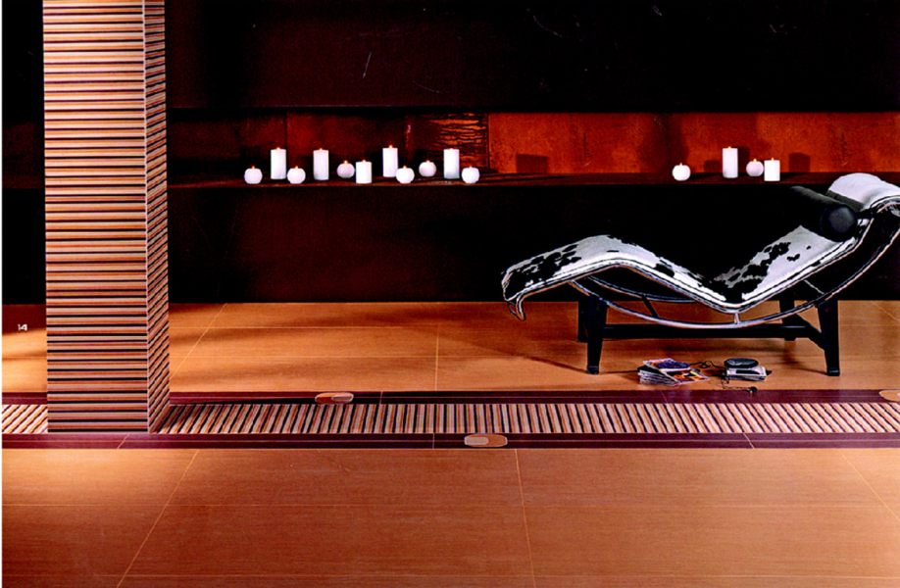 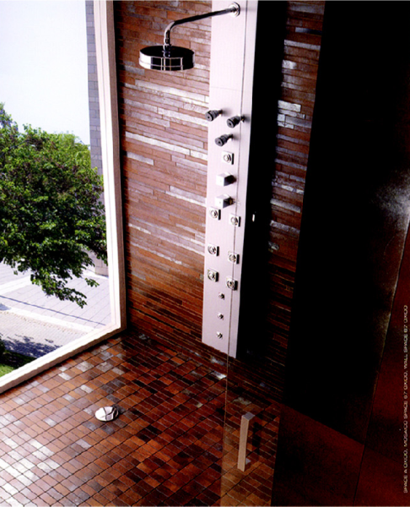

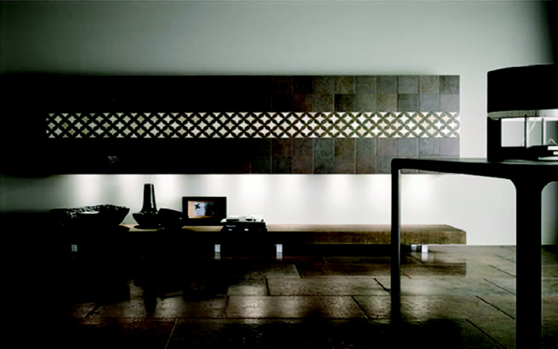 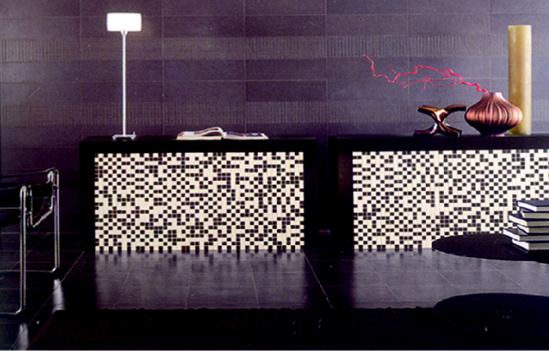

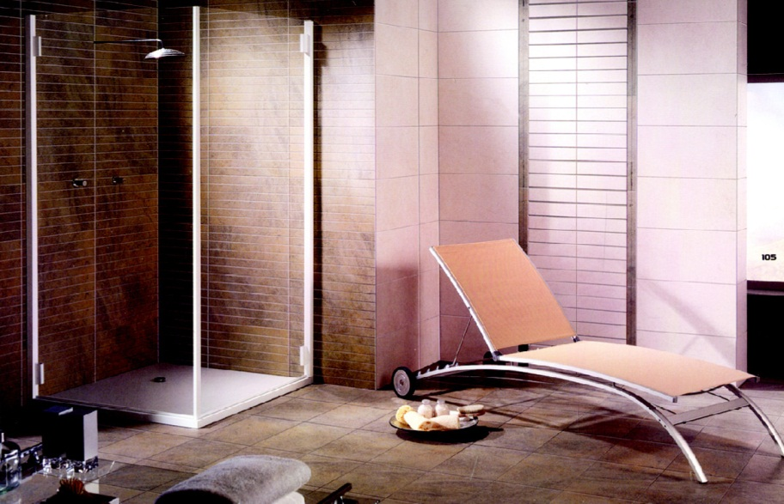 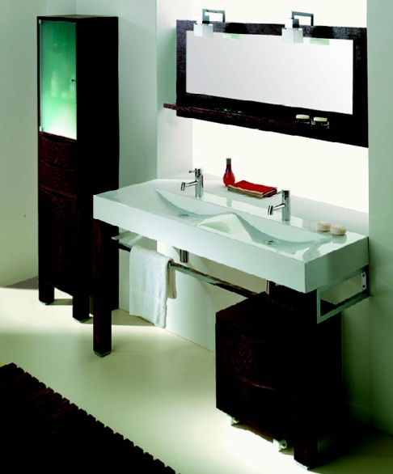

**Services & Portfolio**

|  |
| --- |
|  |

**CUSTOM DESIGN LAYOUT**

We provide our customers with multiple layout specifically tailored to address their need.

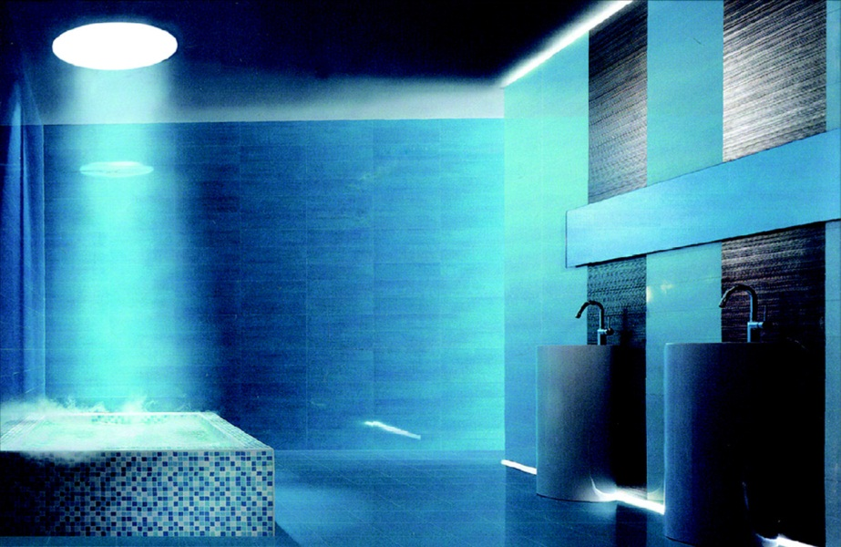 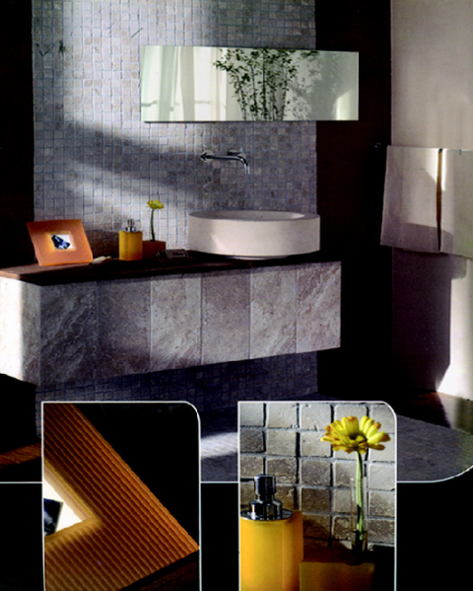

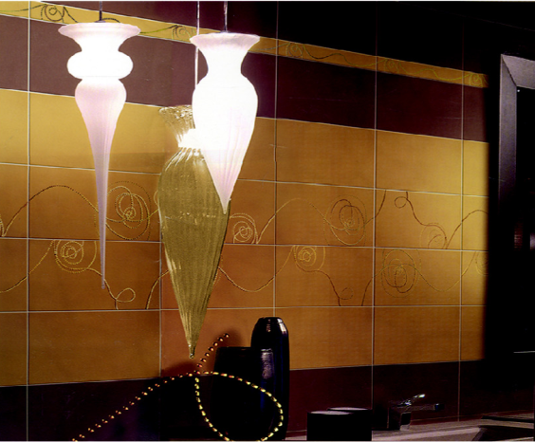 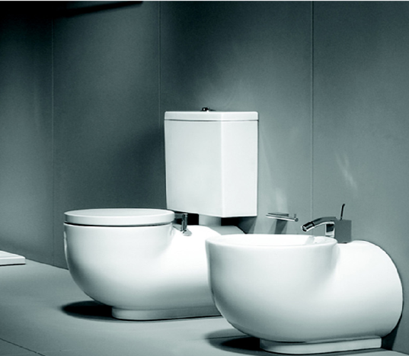

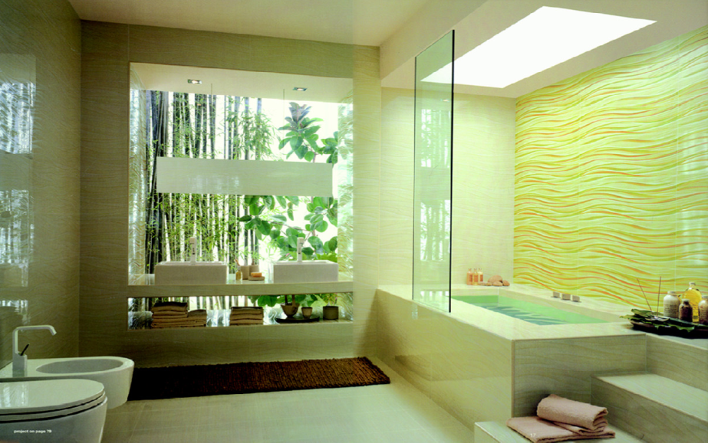 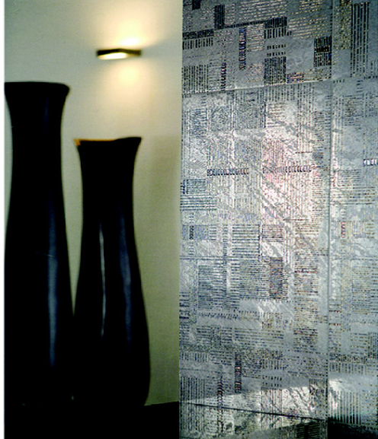

**Services & Portfolio**

|  |
| --- |
|  |

**CUSTOM DESIGN LAYOUT**

We provide our customers with multiple layout specifically tailored to address their need.

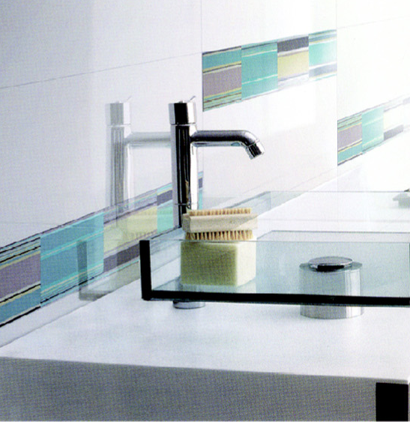

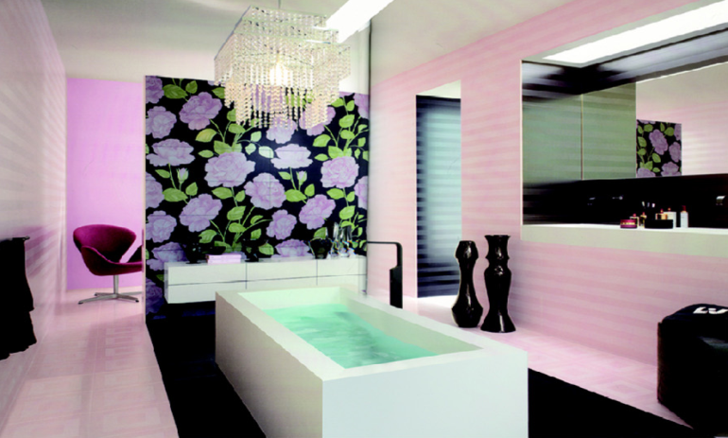

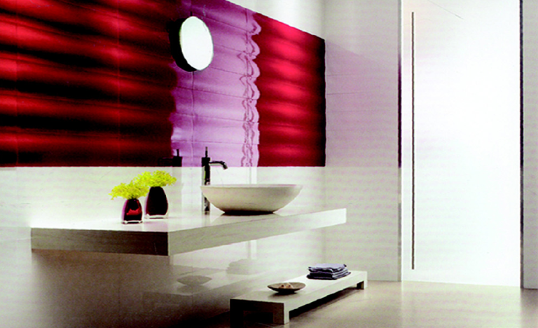 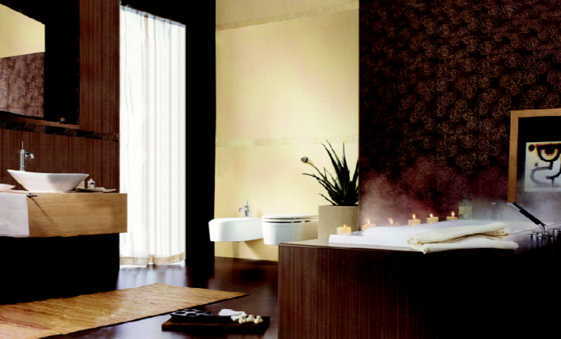

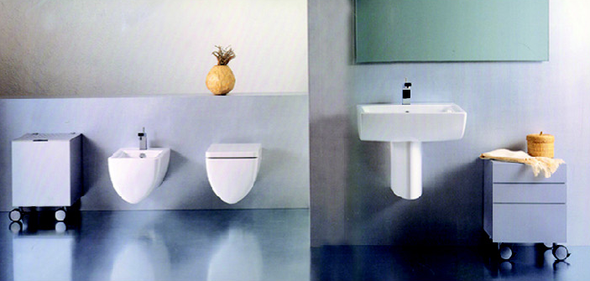

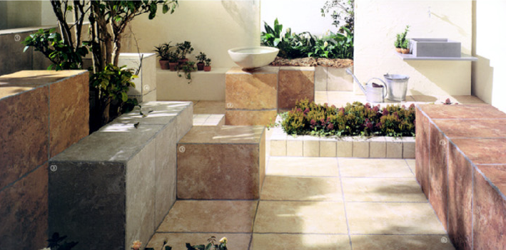

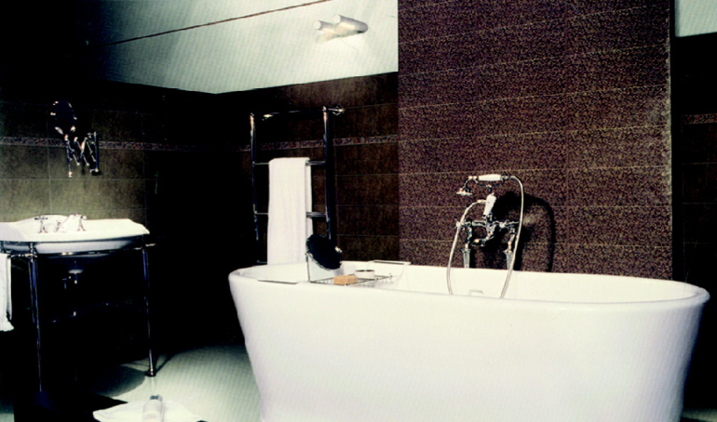

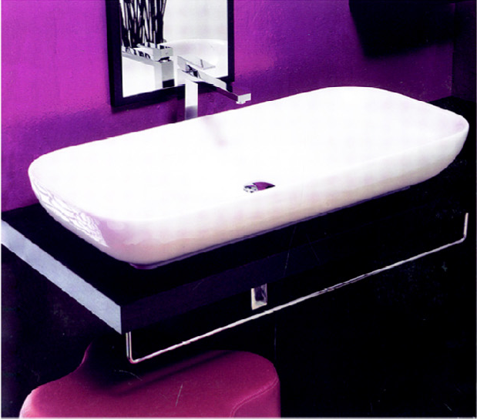

**Services & Portfolio**

|  |
| --- |
|  |

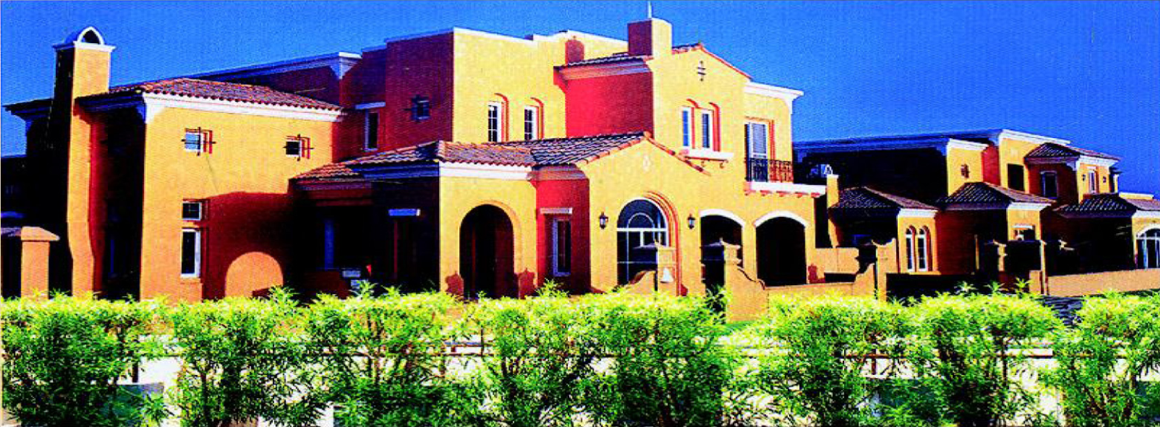

**Arabian Ranches**

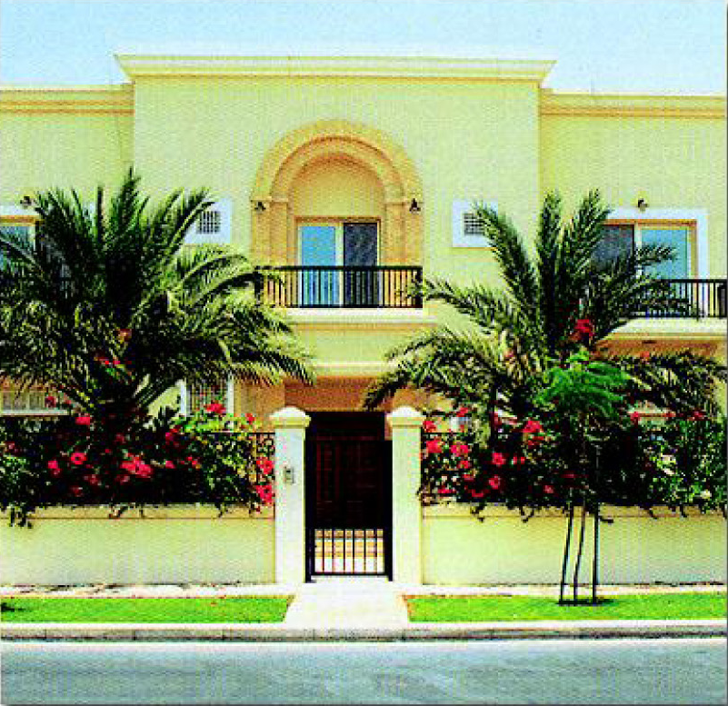

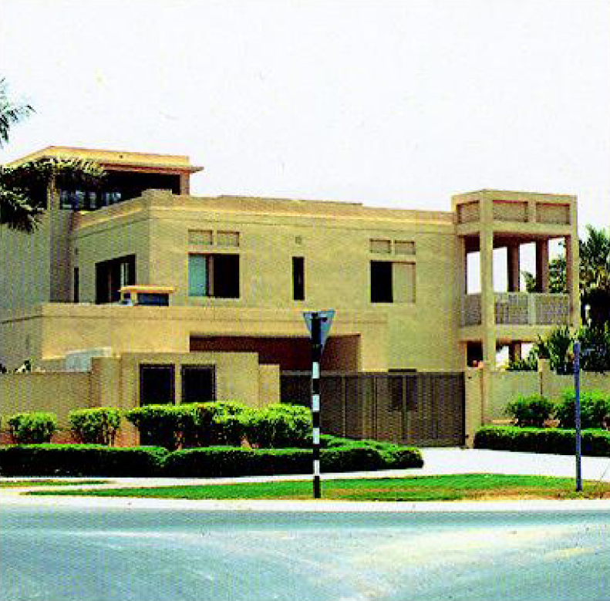

**24 Luxury Villas**

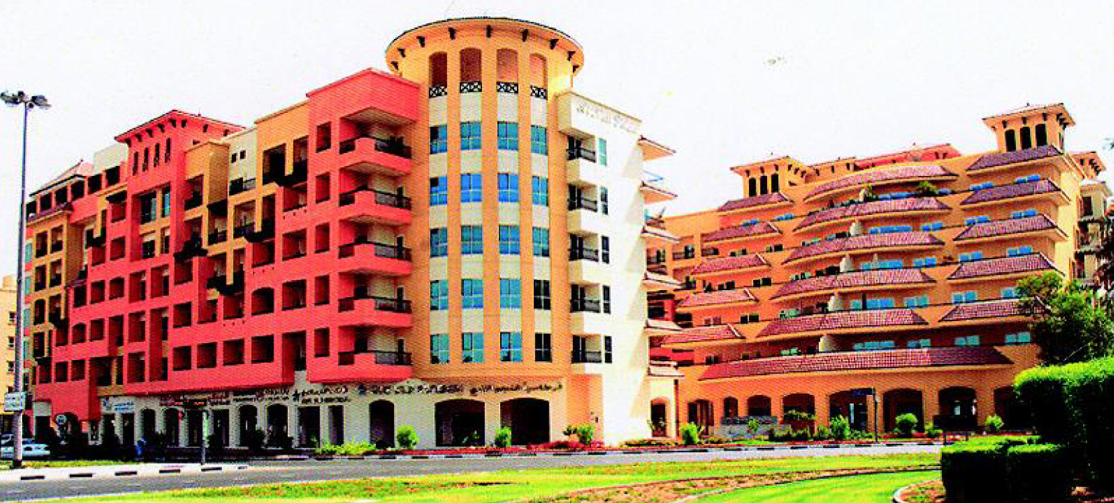

**Al Nasr Sports Club**

**Services & Portfolio**

|  |
| --- |
|  |

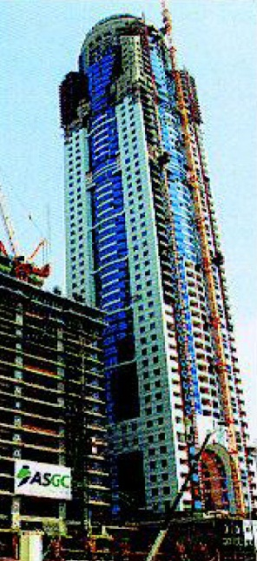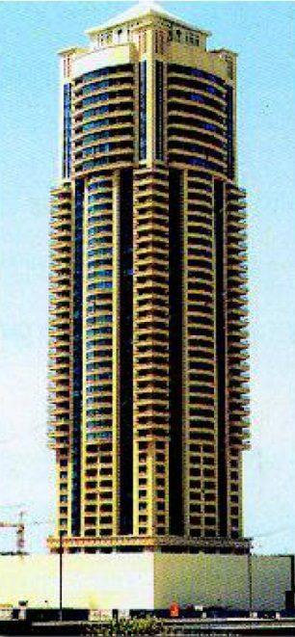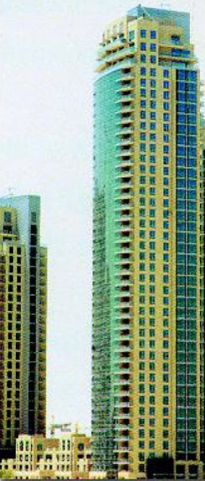

**Phase II Burj Dubai Development**

**Al Seef Tower**

**Al Marsa Tower**

**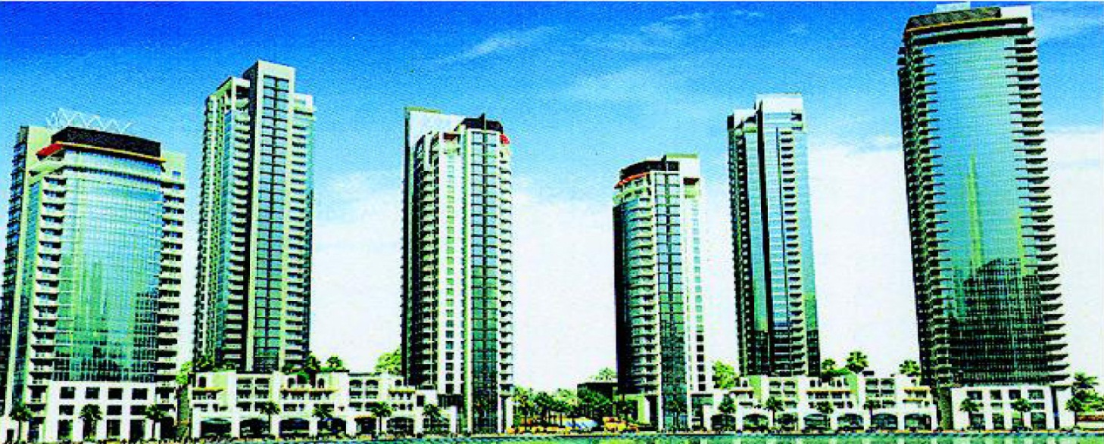**

**Dubai Marina**

**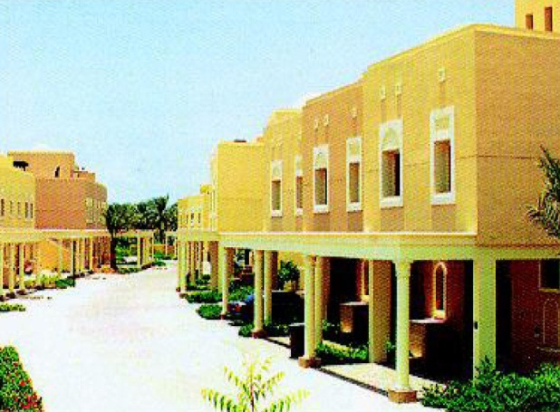 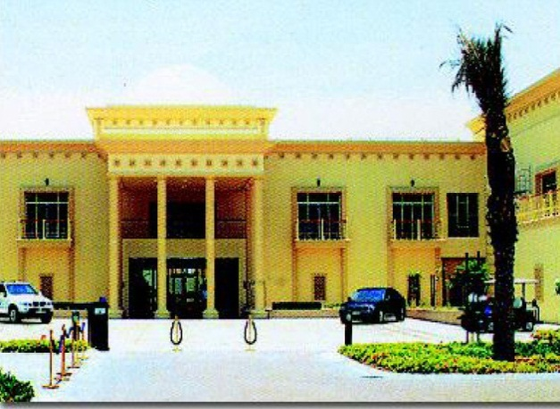**

**Montgomery**

**Masionettes**

**Services & Portfolio**

|  |
| --- |
|  |

**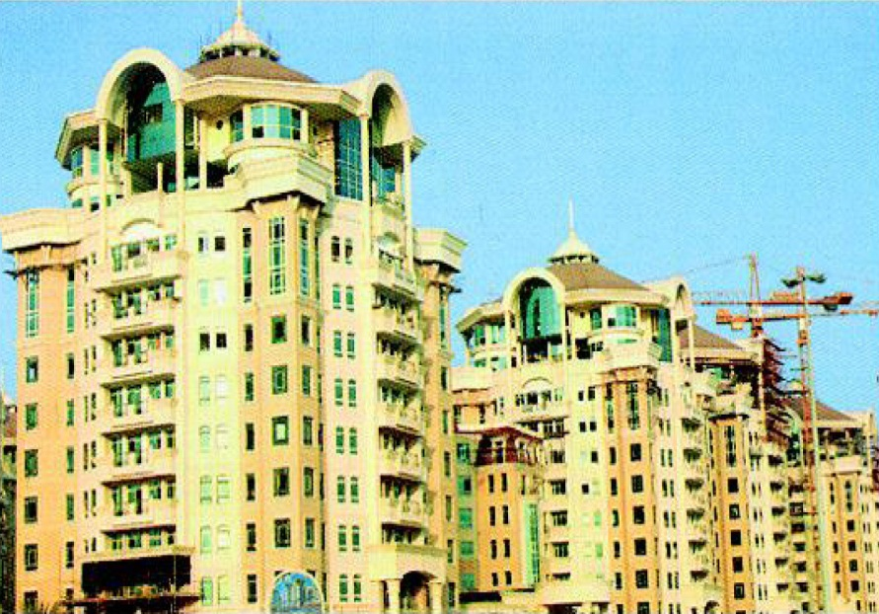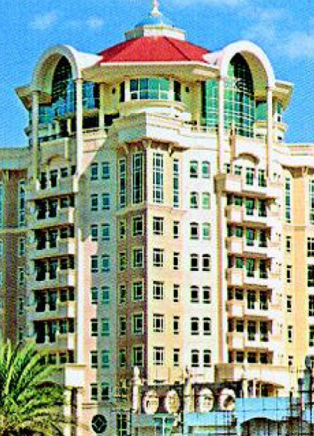**

**Al Murooj Project**

**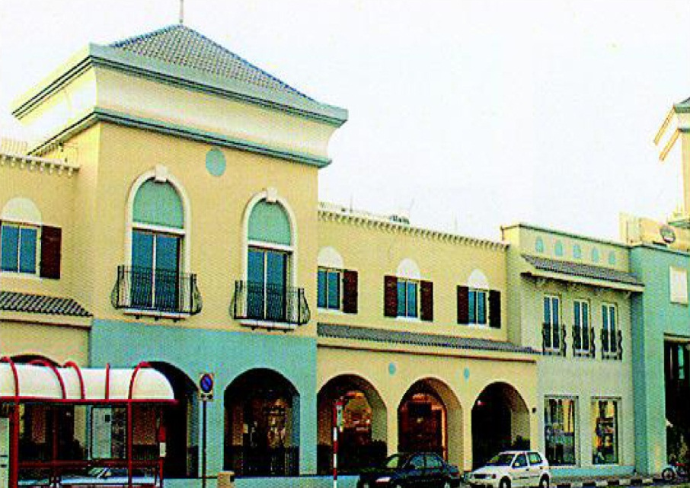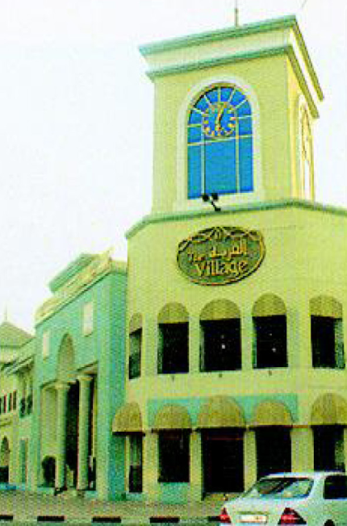**

**The Village**

****

**Dubai Creek Village**

**Major Ongoing Projects**

|  |
| --- |
|  |

|  |  |  |  |  |
| --- | --- | --- | --- | --- |
| **SI No.** | **Project Name** | **Client** | **Consultant** | **Contractor** |
| 1. | Midfield Terminal Project Abu Dhabi, U.A.E. | M/s Abu Dhabi Airports Authority. | M/s Kohn Pedersen Fox Associates | M/s TAV, CCC Arabtec (TCA) Joint Venture |
| 2. | Westin Hotel, Dubai, U.A.E | M/s Al Habtoor Group | M/s Khatib & Alami Eng. Consultants | M/s Habtoor Leighton |
| 3. | ASAS Tower G+5 Car Park+HC+43 Typ. Floor+Pent  House & Pent House | M/s ASAS Real Estate | M/s Gulf International Consultants | M/s Al Qabdah Bldg. Cont. |
| 4. | Gulf Oasis Tower B+G+M+6 Floor (Offices/Parking)+ 2Service Floors +42 Typical Floor, Al Khan Sharjah, UAE. | Mr. Ahmed Ghanem | Al Mazaya Consulting Engineers | M/s Al Qabdah Bldg. Cont. |
| 5. | Hotel Apartment - G+5P+HC+1Serv.+27 Typical Floors at Al Khan, Sharjah, U.A.E. | Mr. Muneir & Mr. Abed Al Salam Al Shareif | Al Mazaya Consulting Engineers | M/s Al Qabdah Bldg. Cont. |
| 6. | G+6 Resi. Bldg. in Sharjah, U.A.E | H.H. Abdul Rahma Mohamed Nasir Al Owais | Al Mazaya Consulting Engineers | M/s Al Qabdah Bldg. Cont. |
| 7. | G+3, Resi. Bldg. @ Moileh, Sharjah, U.A.E. | Mr. Mohamed Adib Hejazi | Al Mazaya Consulting Engineers | M/s Al Qabdah Bldg. Cont. |
| 8. | 2 Typical Bldg.s G+5 Resi. Bldg. @ Moileh, Sharjah, U.A.E. | Mr. Mohamed Adib Hejazi | Al Mazaya Consulting Engineers | M/s Al Qabdah Bldg. Cont. |
| 9. | 4B+G+2P+11+ Roof Mix Use, Plot # C40, Abu Dhabi, U.A.E. | M/s Ali & Son’s Cont. Co. | M/s Al Amarar Al Sharkia. | M/s Ali & Son’s Cont. Co. |
| 10. | 2B+G+29+Mechanical+HC+Resi. Bldg. Dubai, U.A.E. | M/s Al Madar Group. | M/s NEB Eng. Consultants | M/s UNEC Cont. Co. LLC. |
| 11. | 1582 Villas, Mira Tower | M/s Emaar Properties | - | M/s Arabtec |
| 12. | 500 Villas – The Living Legends | Dubai Land Co. L.L.C. | M/s IDP Interiors | M/s Delta Emirates Cont. Co. |
| 13. | H.E. Khalifa Al Naboodah Bldg., Dubai, U.A.E. | M/s Khalifa Al Naboodah Group of Companies | M/s Khatb & Alami Eng. Consulants | M/s Al Sahel Cont. Co. |
| 14. | Palace for H.H. Shaik Majid Bin Faisal Al QAssimi | H.H. Shaik Majid Bin Faisal Al Qassimi | M/s Idea Art Decoration | Trans East Cont. Co. LLC. |
| 15. | Private Palace for H.H. Shaik Ahmed Al QAssimi | H.H. Shaik Ahmed Al Qassimi | M/s Idea Art Decoration | M/s Al Twazun |
| 16. | Private Palace for H.H. Shaik Ahmed Al QAssimi’s Mother | H.H. Shaik Ahmed Al Qassimi | M/s Idea Art Decoration | M/s Al Twazun |
| 17. | Palace at Jumeirah first for VVVIP | Confidential | M/s Rahim Engineering Consultant | M/s Arabian Construction Co. |
|  |  |  |  |  |
|  |  |  |  |  |
|  |  |  |  |  |
|  |  |  |  |  |
|  |  |  |  |  |
|  |  | **Major Ongoing Projects** | | |

|  |
| --- |
|  |

|  |  |  |  |  |
| --- | --- | --- | --- | --- |
| **SI No.** | **Project Name** | **Client** | **Consultant** | **Contractor** |
| 18. | Service Workshop & Offices @ Al Mafraq (P206) | M/s Chawla Group | M/s Chawla Architects & Engineering Consultants | M/s National Projects & Const. L.L.C. |
| 19. | Capital House – C19, Abu Dhabi | M/s Ali & Son’s Cont. Co. | M/s AE Com. Engineerin Consultants | M/s Ali & Son’s Cont. Co. |
| 20. | FGB Arena, Abu Dhabi | M/s Reem Investments | M/s Obermeyer Middle East GMBH | M/s Max Bogl Emirates Bldg. Cont. |
| 21. | Oceanic Hotel, Khurfakhan | M/s Oceanic Hotel | M/s Idea Art Decoration | M/s Space Builders L.L.C. |
| 22. | Refurbishment & Extension Works for Grand Hotel, Sharjah. | M/s Grand Hotel Sharjah | - | M/s Dhafir Dev. & Cont. L.L.C. |
| 23. | Different Facilities @ Falag Al Moalla Palace | Crown Prince Cour, Abu Dhabi. | - | Capriole Construction L.L.C. |
| 24. | Abu Dhabi Health Club | M/s Country Club | - | Capriole Construction L.L.C. |
| 25. | 69 Villas @ Dubai Land. | M/s National Bond. | M/s IDP Interiors | M/s Metac Gen. Cont. Co. |
| 26. | Community Clinic, Fire Station & Service Yard @ Zabeel | M/s Engineer’s Office | - | M/s Union Cont. Co. L.L.C. |
| 27. | Kempenski Fit Out, Mall of Emirates | M/s Kempenski Hotel | - | M/s ISG Middle East. |

**Major Completed Projects**

|  |
| --- |
|  |

|  |  |  |  |  |
| --- | --- | --- | --- | --- |
| **SI No.** | **Project Name** | **Client** | **Consultant** | **Contractor** |
| 1. | G+M+70 Com & Res Bldg Tower @ Shk Sayed Road | M/s.Dubai International Real Estate | M/s Al Hashemi Consultants | M/s Al Ahmadiah Trdg. & Contracting Co. |
| 2. | Beach Front Residential Dev. Villas, Jumeirah, Dubai | M/s.Dubai International Real Estate | M/s Dewan Al Emara | M/s Al Ahmadiah Trdg. & Contracting Co. |
| 3. | Residential Complex at Oud Metha, Dubai | M/s.Dubai International Real Estate | M/s Dewaan Architects & Egineers | M/s Al Oroba Contracting LLC |
| 4. | 2B+G+30 Floors Res Bldg at Al Nahda 1st, Dubai | M/s.Dubai International Real Estate | M/s Group Consult Int’l | M/s Al Habbai Contracting Co. |
| 5. | B+G+19 Floors Res Bldg At Al Nahda 1st, Dubai | M/s.Dubai International Real Estate | M/s Al Gurg Consultants | M/s Bin Belaila Contracting Co. |
| 6. | B+G+M+5 Com & Res Bldg at Souk Al Khabeer, Dubai | M/s.Dubai International Real Estate | M/s Hegazy Engineering Consultants | M/s Al Ashram Contracting LLC |
| 7. | 2B+G+30 Floors Res Bldg at Nahda 1st, Dubai | M/s.Dubai International Real Estate | M/s Group Consults Int’l | M/s Al Habbai Contracting Co. |
| 8. | 22 Villas (G+1) + Commercial Block @ Jumeirah 1st, Dubai | M/s.Dubai International Real Estate | M/s Hegazy Engineering Consultants | M/s Bin Belaila Cont. L.L.C. |
| 9. | 3B+G+4+Gym Comm. Res. Bldg. @ Al Karama, Dubai | M/s.Dubai International Real Estate | M/s Design Center Arch. & Engr. Consultants | M/s Al Habbai Contracting Co. |
| 10. | 4 Investment Bldgs. B+G+12 Resi. Bldgs @ Al Nahda | M/s.Dubai International Real Estate | M/s Al Fahidi Engr. Consultants | M/s Bin Zayed Cont.  L.L.C |
| 11. | Al Murroj Complex | M/s.Dubai International Real Estate | Artec | Al Ahmadiah Trading & Contracting Co. |
| 12. | The Villa-Phase I & II at Dubai Land | Dubai Properties | Shadid Engineering Consultants | Al Shafar General Contracting Co. |
| 13. | Business Bay Executive Towers | Dubai Properties | Design & Architects Bureau (DAR) | Al Habtoor Eng. |
| 14. | G+2B+HC+25 Tiffany Tower (4 Towers) @ IMPZ | Eta Star Properties | Ntional Eng. Bereau | Civilco Engineering & Cont. Co. LLC |
| 15. | Jumeirah Village: Triangle Zone-2 | Nakheel | Dar Al Handasah | Nurol LLC |
| 16. | Jumeirah Village: Triangle Zone-2 | Nakheel | Dar Al Handasah | Gunal LLC |
| 17. | Al Maqam Palace, Al Ain | H.H. Sheikha Fatima | Director of Military Works (DMW) | Capriole Conts. Company LLC |
| 18. | Al Mina Palace, Abu Dhabi | H.H. Sheikh Haza Bin Zayed Al Nahyan | Director of Military Works (DMW) | Capriole Conts. Company LLC |
|  |  |  |  |  |
|  |  |  |  |  |
|  |  | **Major Completed Projects** | | |

|  |
| --- |
|  |

|  |  |  |  |  |  |  |  |  |  |  |  |  |
| --- | --- | --- | --- | --- | --- | --- | --- | --- | --- | --- | --- | --- |
| **SI No.** | | **Project Name** | | | **Client** | | **Consultant** | | | **Contractor** | | |
| 19. | Ghazlan Island, Abu Dhabi | | | H.H. Sheikh Haza Bin Zayed Al Nahyan | | Director of Military Works (DMW) | | | Capriole Conts. Company LLC | | | |
| 20. | Diplomatic Club, Abu Dhabi | | | H.H. Sheikh Haza Bin Zayed Al Nahyan | | Director of Military Works (DMW) | | | Capriole Conts. Company LLC | | | |
| 21. | Palace for H.H. The Chairman of Dubai Municipality | | | H.H. Shk. Hamdan Bin Rashid Al Maktoum | | Bin Shadid Consultants | | | Bin Ladin Contracting Company | | | |
| 22. | Awir Housing Dev’t. | | | Al Naboodah Real Estate & Investments | | Online Architects | | | Al NAboodah Cont. LLC | | | |
| 23. | Between the Bridges Resort | | | Roya International | | Keo International | | | Al JAber Energy Services | | | |
| 24. | The Lofts: Burj Dubai Dev’t. | | | Emaar | | AK Design | | | Al Futtaim Carillion LLC | | | |
| 25. | Lake Shore Tower – 1 at JLT, Dubai | | | Capital Investments | | Khatib & Alami | | | Pivot Eng. & Gen. Cont. WLL | | | |
| 26. | Gold Crest Views – 2, Dubai | | | Eta Star Properties | | WS Atkins | | | Al Meraikhi Gen. Cont. Co. | | | |
| 27. | Global Lake View Tower at Jumeirah Lake Towers, Dubai | | | Best Homes | | WS Atkins | | | China State Cont. Engineering Corp. | | | |
| 28. | Tanweel Tower at Jumeirah Lake Towers, Dubai | | | Tamweel Properties | | DAR Consultants | | | Civilco Eng. & Cont. LLC | | | |
| 29. | Emirates Airline Apartments | | | Emirates Airlines | | Frezer Nag | | | Al Nehkre Cont. Company LLC | | | |
| 30. | Construction of Community Centre at SFZ | | | Emirates TechnoCast FZE | | Al Deira Engineering Consultants | | | Amana steel Blsg. Cont. | | | |
| 23. | Labour Accommodation at Al Quoz | | | M/s.Dubai International Real Estate | | | | Alo Bonian Eng. Consultants | | | Bin Shafar Contracting LLC | |
| 24. | Holidya Inn, Dubai | | | Splendid Group | | | | Splendid Group | | | Splendid Hotel Grp. | |
| 27. | Al Hoton Tower, Dubai | | | Mr. Firas Ali | | | | Emirates Consultants Group (ECG) | | | Robust Cont. Company LLC | |
| 28. | Com & Res Building | | | Nandhra Engineering & Cont. Co. Ltd. | | | | Nandhra Engineering | | | Nandhra Eng. & Cont. Co. LLC | |
| 29. | SH-02 G+3P+10 TYP, Abushagara, Sharjah | | | Omran Tarium & Sons | | | | Gulf Consultants | | | Cast Const. LLC | |
| 33. | 2B+G+12 Residential Bldg., Al Ghusais | | | Saud Bahwan Group | | | | Holdfords Associates | | | Belhasa Eng. | |
| 34. | G+M+5, Rais Hassan Saadi Building | | | Mr. Rais Hassan Saadi | | | | Al Hilal Consultants | | | Emirates Gen. Co. | |
|  |  | | |  | | | |  | | |  | |
|  | | |  | | | |  | | |  | |
|  |  | | |  | | | |  | | |  | |
|  |  | | |  | | | |  | | |  | |
|  |  | | **Major Completed Projects** | | | | | | | | |
|  |  | | |  | | | |  | | |  | |

|  |  |
| --- | --- |
|  |  |
|  | |

|  |  |  |  |  |  |  |  |
| --- | --- | --- | --- | --- | --- | --- | --- |
| **SI No.** | | **Project Name** | | **Client** | **Consultant** | **Contractor** | |
| 1. | | Burj Dubai Dev’t. Burj Residences Phase III | Emaar | | Arif & Bintoak | | Nasa Multiplex LLC |
| 2. | | Burj Dubai Dev’t. Burj Residences Phase II | Emaar | | Arif & Bintoak | | Nasa Multiplex LLC |
| 3. | | Dubai Marina 7W & 7X | Emaar | | Arif & Bintoak | | Nasa Multiplex LLC |
| 4. | | Luxury Marina Villas at Abu Dhabi | H.H. Sheik Mohd. Bin Sayed Al Nahyan | | Dewaan Al Emara | | Intermass Engineering & Contracting Co. LLC |
| 5. | | Port Rashid Terminal, Dubai | M/s Dubai Ports & Customs | | A. Davies | | Al Hamad Cont. Co. |
| 6. | | Emirates Airlines Apt., Dubai | M/s Emirates Airlines | | Khatib & Alami | | Al Shafar Gen.Cont. Co. |
| 7. | | The Village, Dubai | M/s.Dubai International Real Estate | | Holfords Associates | | Al Shafar Trans. & Cont. Co. LLC |
| 8. | | Sharjah Ladies Club | M/s Ministry of Public Works Sharjah | | M/s Sharjah Ladies Club | | M/s Mzoon Bldg. Cnt. |
| 9. | | Arabian Ranches Development | Emaar | | Godwin Austeen Johnson | | M/s Arabtec |
| 10. | | Palm Jumeirah Shoreline Apartments, Dubai | Nakheel | | Ace International | | DEPA Interiors LLC |
| 11. | | Palm Jumeirah Shoreline Apartments, Dubai | Nakheel | | Ace International | | JC Maclean Int’l. |
| 12. | | Palm Jumeirah Shoreline Apartments, Dubai | | Nakheel | | Ace International | | Kocache Décor & Contracting Co. |
| 13. | | Palm Island Signature Villas, Dubai | | Nakheel | | Keo International | | Al Hashem Marble Co. |
| 14. | | 92 Villas for Dubai Creek & Golf Yatch Club | | Dubai Creek & Golf Yatch Club | | Godwin Austeen Johnson | | Convrgnt Value Engineering LLC |
| 15. | | 23 Emmar Villas, Dubai | | Emaar | | Frayland Interiors | | Frayland Cont. & Interiors |
| 16. | | DIFC Gate Village, Dubai | | DIFC | | Hopkins | | Arabtec |
| 17. | | Emirates Bank International Building, Sharjah | | Emirates Bank Int’l | | Khatib & Alami | | Gustav & Pegel Sohn LLC |
| 18. | | Rotana Hotel, Al Ain | | Rotana Group | | Al Salam Consultants | | Al Faraá General Contracting Co. |
| 19. | | TSC Discount Store, Muscat | | Sultan Center | | Sultan Center | | Sultan Center LLC |
| 20. | | Dubai Mall | | Emaar | | Turner | | Leader Interior Fitout Décor LLC |
|  | |  | |  | |  | |  |
|  | |  | |  | |  | |  |
|  | |  | |  | |  | |  |
|  | |  | | **Major Completed Projects** | | | | |
|  | |  | |  | |  |

|  |  |
| --- | --- |
|  |  |

|  |  |  |  |  |  |  |  |  |  |
| --- | --- | --- | --- | --- | --- | --- | --- | --- | --- |
| **SI No.** | | **Project Name** | **Client** | | **Consultant** | | **Contractor** | | |
| 21. | | U-2 Tower/Jumeirah (3B+G+39 Storey Bldg.) | | | Deyaar Development | | Dar Consultants | | Ascon Cont & Investments Co. LLC |
| 22. | | Park Palace Tower Sheikh Zayed Road Dubai | | | Humaid Bin Drai | | Higgs & Hills | | Arabian Const. Co. |
| 23. | | C3 & U1, U2 Com & Res Tower at Jumeirah Lake Tower | | | Deyaar Properties | | Dar Consultants | | Ascon LLC |
| 24. | | Gold Crest, Jumeirah Lake Towers | | | Eta Star Properties | | WS Atkins | | Al Habtoor Eng. |
| 25. | | Manchester Tower, Dubai | | | Mr. Lanjawi | | Al Hatmy Eng. | | Al Hamad Cont. Co. |
| 26. | | The Views, Res. Dev’t., Dubai | | | Emaar Properties | |  | | Frayland LLC |
| 27. | | Liwa Height, Dubai | | | North Croft Middle East | | Keo International | | Dhafir Development & Contracting LLC |
| 28. | | Al Marza Tower, Dubai | | | Al Naboodah Real Estate | | Khatib & Alami | | Al Naboodha Cont. Co. |
| 29. | | Le Meridien Hotel, Abu Dhabi | | | Le Meridien Group of Hotel | | Le Meridien | | Fautaeh Furniture |
| 30. | | Shar-E-Aftab Residential Complex, ish Island, Iran | | | Al Bina Project | | Al Bina Project Managements | | Al Bina Project |
| 31. | | Madina Towers, Jumeirah Lake Towers, Dubai | | | Reef Real Estate | | Keo International | | Emirates Belbadi Cont. Co. LLC |
| 32. | | Al Seef Tower, Dubai | | | Dubai Islamic Bank | | Dar Consultants | | Al Habtoor Eng. |
| 33. | | Al-Owais Building | | | Al-Owais Investments | | Khatib & Alami | | NSCO Bldg. Cont. |
| 34. | | B+G+12 Typ at Nahda – 11 | | | Mr. Saleem Ahmed Mohd Al Falahi | | Gulf Consultants | | Al Memzar Cont. Company LLC |
| 35. | | Diamond – at Al Marsa, Dubai | | | Diamond Investments | | Al Ajmi | | Belhasa Eng. |
| 36. | | G+5P+25 Res. Bldg. at Al Nahda | | | Mohd Hassan Baba Hassani | | Rahim Engineering Consultants | | Hassan Group of Companies |
| 37. | | Com & Res Building at Muraqabad (PO41) | | | AL Ghurair Investments | | Arif & Bintouk | | Al Rostamani Pegel LLC |

|  |  |  |  |  |
| --- | --- | --- | --- | --- |
|  | **Quality Manual** | | | |
|  |  |  |  |

|  |  |
| --- | --- |
|  |  |

Supplier Address: **NAZO BUILDING MATERIALS TRDG.EST**

Telephone Number: **+971-6-567 1221 / +971-6-567 1511**

Approved by: **Mr. MOHD ABDEL RAZEK**

**SALES DIRECTOR**

Mr. MOHD ABDEL RAZEK \_\_\_\_\_\_\_\_\_\_\_\_\_\_\_\_\_\_\_\_\_\_\_\_\_\_\_\_\_\_ (Signature)

Prepared By**: Quality Assurance Officer**

**Mr. BOBBY** \_\_\_\_\_\_\_\_\_\_\_\_\_\_\_\_\_\_\_\_\_\_\_\_\_\_\_\_\_\_ (Signature)

Submitted By: **Warehouse Manager**

**Mr. Sandeep Kaul** ------------------------------------------------- (Signature)

**Review by: By Management**

**Table of Contents**

|  |  |
| --- | --- |
| Section No. | Section Heading |
| 1 | General Introduction |
| 2 | Organization Chart for the Company |
| 3 | Quality Policy |
| 4 | Physical Tests to be conducted at Warehouse |
| 5 | Quality System |
| 6 | Quality Assurance Dept. Organization Chart |
| 7 | Job Descriptions of Quality Assurance Department |
| 8 | Document Control |
| 9 | Quotation Procedure |
| 10 | Traceability of Measurements |
| 11 | Review of Contracts |
| 12 | Engineering & Design |
| 13 | Procurement Process |
| 14 | Review of all Results by QAO |
| 15 | Receiving Inspection |
| 16 | Material Control & Sourcing |
| 17 | Production Control – Cutting Activities |
| 18 | Control of Special processes |
| 19 | Packing & Shipping |
| 20 | Control & Calibration of Test Equipment / Test Procedures |
| 21 | Internal Quality Control Procedures |
| 22 | Control of Non-Conformity |
| 23 | Corrective Action Procedure |
| 24 | Preventive Action |
| 25 | Complaints and Feedback |
| 26 | Internal Audit and Data Review |
| 27 | Reporting Analytical Results |
| 28 | Records |
| 29 | Confidentiality and Proprietary Rights |
| 30 | References |
| 31 | Code of Ethics |
| 32 | Appendix |
|  | Appendix A – General Flow Chart of Nazo’s system |
|  | Appendix B – General Organization Chart |
|  | Appendix C – QA Dept. Organization Chart |
|  | Appendix D – Document Control – List of documents |
|  | Appendix E - Flow Chart & Job Description of QC in Cutting |
|  | Appendix F – Control of Special Process – Cutting Dept. |
|  | Appendix G – Procurement Flow Chart |
|  |  |

1. **General Introduction about Company**

Nazo Building Materials Trading Est. located in the heart of Sharjah, is a leading Supplier of Modern, High Quality Porcelain and Ceramic Tiles and also the Sanitary Wares & Accessories. Nazo Building Materials Trading Est. was formed in the year 1982 and has branches in Dubai, Sharjah Industrial Area and Fujairah.

We have taken care to partner and associate with leading manufacturers of Ceramic tiles from Italy, Spain, Turkey, South America, China and Far East to meet the demands of this constantly changing market. Encouraged by EXPO 2020 and the subsequent growth of property market & the real estate in the region, we at Nazo Building Materials Trading Est. are equipped to meet the growing demands for Ceramic products.

**Our Bifurcations are as follows**;

1. Nazo Building Materials Trading Est. , Al Wahda Road Sharjah ( Main Showroom& Head Office)

**Floor Area: 21,520.00 sq. ft**.

1. Nazo Building Materials Trading Est. BWW junction(Industrial Area), Sharjah (Showroom Branch)

**Floor Area: 5,380.00 sq. ft**

1. Nazo Building Materials Trading Est. Fujairah ( Showroom Branch )

**Floor Area: 5,380.00 sq. ft**

1. Ceramic City LLC, Dubai ( Dubai Showroom)

**Floor Area: 5,380.00 sq.ft**

1. Nazo Ajman Warehouse ( Central Warehouse for all the Showrooms)

**Floor Area: 107,600 sq.ft**

1. Nazo Cutting Factory at Ajman ( For Cutting requirements such as Skirting, Rectification & Waterjet Design Cutting)

**Floor Area: 21,520.00 sq.ft**

**Main Objective**

* Our Main Objective is to supply materials (Ceramic tiles & sanitary wares) to our Customers/Clients, receiving in our Warehouse from Far East countries.
* We are not into manufacturing sector whereas we are managing one cutting factory to make Skirtings, Rectification of Tiles, Adjust the tiles as per Clients requirements, Water jet design in line with Client’s requirements etc.
* We have an effective Quality Control System to make sure that Quality Assurance is properly taking care of to avoid complaints from Clients/Customers.

**General Flow Chart of Nazo’s System**

Refer **Appendix A** for the General Flow Chart of Nazo’s working system

1. **Organization Chart**

Refer **Appendix B** for General Organization Chart

Organization Chart is attached in the Pre-Qualification Documents also.

1. **Quality Policy**

It is Nazo’s objective to provide Quality materials to the Clients of all projects dealing with our company. The materials for Supply are being brought from Far East Countries, where most of the manufacturers are accurately and precisely following the ISO procedures as well as ISO accreditations. Demonstration of Nazo’s commitment to reach its objective will result in the following:

\* Adequately staffed and equipped Showroom facility, Warehouse facility, Design Facility, Cutting facility etc.

\* Successful implementation of a well-equipped Quality system,

\* Annual internal audits with Management review,

\* Timely reporting of Physical test results on all the new stock arriving in Ajman Warehouse, to the Sales Director

The quality policy is communicated to employees during the training of new hires. It is understood, implemented, and maintained by employees at all levels. This is documented by management through the employee evaluation process. The Sales Director shall assure that the Quality Manual is communicated to, understood, and implemented by all personnel concerned.

**4 Physical Tests to be conducted at Warehouse**.

**Test**

* Quantity Checking
* Pallet Checking for packing’s
* Broken Tiles if any in boxes
* Actual Size Vs. Received Size
* Tonality & Caliber checking
* Name & Logo of Tiles.
* Surface Flatness

Quality Procedures for the Examination of above tests are as follows;

1. **Quantity Checking**: Once the shipping documents for the materials after customs clearances reaches the Warehouse, the QC Team will check each and every pallets and boxes in order to verify whether the ordered quantities are received at store.
2. **Pallet Checking**: Each Pallet will be checked for defective packing if any occurred from the manufacturer’s end and will be documented for management’s review.
3. **Broken Tiles checking**: Once the Pallets are thoroughly checked, the boxes from each pallet will be taken randomly and open for breakage if any. If any broken tiles are seen in any boxes, such boxes will be separated from the whole package and will be stored separately for management review and for the inspection of factory representatives. Once the inspection from management and factory is completed, the same will be discarded from the entire area to the dump yard.
4. **Actual Size vs Received Size** : Random boxes in each pallet will be opened and checked for the size of the received tiles in line with the actual required sizes provided by the manufacturer. The testing will be in line with the EN 14411 European Standards and if any of the tiles are deviating from the tolerance limit mentioned in the specifications, such tiles will be separated and documented and will be send for review of management & factory representatives. After inspection, such tiles will be discarded from Warehouse.
5. **Tonality & Caliber Checking**: Tiles from Random boxes from each pallet will be checked for Tonality & Caliber in line with the EN 14411 European Standards and if any deviations above tolerance limit will be discarded as mentioned above. Also each tonality will be grouped together and the clients will be informed accordingly to use same tonality & same caliber in separate areas.
6. **Name & Logo of the manufacturer**: Unless otherwise specified, the pallets and boxes without Name & Logo of the respective factory will be discarded s mentioned above.
7. **Surface Flatness**: The tiles from randomly selected boxes will be checked for surface flatness and the maximum deviation from flatness in percentage should tally with the E ISO 10545-2.

**5**. **The Quality System**

The quality system defined in the quality manual applies to all personnel who perform activities affecting quality. All employees are responsible for the quality system. The individual documents define specific employee responsibilities.

Through a formal documented system of planned activities, the quality system meets of the relevant physical test requirements of EN ISO 10545-2. The quality manual is maintained current and up-to-date by the Quality Manager (QAO) to reflect changes to the system. The Warehouse Quality team defines its policy for each applicable standard element in the quality manual. For each element, as appropriate, the Warehouse has documented procedures that further describe how the specific policy objectives and goals are met. The Quality Manual, references these documented procedures. Where applicable, work instructions are referenced in the documented procedures and the quality manual.

Quality procedures and instructions are implemented as written above.. The procedures explain how the Quality team implements the standard requirements in accordance with its quality policy. They are revised, as necessary, to reflect the actual objectives, flow of tasks, and staff responsibilities.

The Work instructions are approved by the affected managerial staff and are maintained in the document control system.

**6**. **Quality Assurance Department Organization Chart**

A well-organized Quality Assurance Department is working in Nazo’s Warehouse, for checking the Quality levels of materials receiving from European & Other Far East Countries.

Refer **Appendix C** for the Organization Chart.

The QA Dept. is comprised of

1. Mr. MOHD ABDEL RAZEK , Sales Director (SD)
2. Mr. SANDEEP KAUL, Warehouse Manager (SM)
3. Mr. Bobby Jain , Quality assurance Officer (QAO)
4. Mr. Habib Mohd, Asst. Quality Assurance Officer (Foreman)
5. Technicians

**7.** **Job Descriptions of QA Staff**

**Sales Director (SD)** - The Sales Director has overall responsibility for the technical operation of the Quality team at the Warehouse. The SD is also responsible for arranging and overseeing all support services including instrument service contracts, subcontracting sample analyses, and physical maintenance of the Warehouse. The SD also interacts with departmental, interdepartmental and appointed/elected officials to participate in coordination of Nazo’s participation in departmental/ interdepartmental projects.

**Warehouse Manager (SM):** The Quality Assurance Officer is directly reporting to the Warehouse Manager (SM) who is familiar with test procedures, the objective of the testing and the assessment of results. He will be in charge of the supervision on Quality team headed by QAO. SM will report directly to the Sales Director and is attending in the meeting with Management for Review meetings.

**Quality Assurance Officer (QAO)** - The quality assurance officer has responsibility for the quality system and its implementation. The QAO has direct access to the Stores Manager and reports directly. In the absence of QAO, deputy shall be appointed for conducting QC checking.

**Asst. Quality Assurance Officer (AQAO):** The AQAO will report directly to QAO and he is the Foreman in charge of the Technicians who are directly working on the test methods. The initial report and readings are being reported by deputy and timely cross checking by QAO.

**Quality Control Technicians**- – Skilled laborers are trained as Technicians and are responsible for performing appropriate QC checks, and informing the QAO when problems occur.

**8.** **Document Control**

All operating procedures, manuals including this quality manual, and documents are subject to document control. Distribution of controlled documents is limited to those indicated on the document distribution list. Controlled documents are recorded and are stored in server as Back up files. The QAO is keeping the QC records and one copy will be forwarded to SD, Stores Manager & Logistics Department.

The purpose of the document control system is to ensure that only the most recent revisions are available to the appropriate personnel, revisions are timely, and receive the required approvals. All internal regulatory documentation, standard operating procedures, work instructions, and product instructions are under document

control. The QA/QC documents and other correspondences details are being stored by concerned departments keeps a master list of the location of all documents in Administration Department. The SD and the QAO approve all newly released documents and revised QC documents. Any employee can request a change to a document. Obsolete documents may be retained for legal reasons or for knowledge preservation. The QAO keeps retained obsolete documents. All documents produced by the Quality Team will contain the following information:

• Effective date,

• Document number,

• Page numbers (including total number of pages), and

• Document title.

Controlled documents will also include an approval signature page, a revision (change record) history page, and distribution list.

All the internal controlled documents are reviewed once per year. If a document is revised during the year the revision record in the document shall demonstrate review. If a document has not been revised during the year, the review record shall be the signature of the person responsible for the document and the date of the review.

Amendment of documents is allowed. The document control system allows for amendment of documents by hand pending re-issue. Such amendments are clearly marked, initialed and dated. A revised document is formally re-issued as soon as practically possible.

All data, including original observations, calculations and derived data, calibration records, QC records, and copies of the test reports, resulting from the analyses of samples are recorded and kept for five years (ten years for potable water samples) to allow historical reconstruction of the final result.

Also, the document control system followed in the Main Showroom is also mentioned in the Appendix D

Refer **Appendix D** for the list of all documents

**9**. **Quotation Procedure**

Nazo is following a formal Quotation procedure. The Quotations are preparing based on the following conditions;

1. Once the Showroom Materials are selected by the Client, Nazo will make a least priced quotation showing Name of the materials, Size, Unit, quantity, Unit Price and Total Price in AED. Based on this Quotation, Client should pay the full amount as advance (if all materials are available in Ex- Stock) and the materials will be delivered to client within a couple of days.
2. For large projects, Nazo will propose materials with matching samples to the client along with priced Quotation. Once the materials are selected by the client, the Quotation will be revised to the selected materials and final prices will be agreed with client based on the Quotation.

The skeleton of Quotation (including type of tiles, size, price etc.) will be forwarded to the secretary by Sales & Marketing Division and Projects Division and the draft quotation will be submitted back to them for final checking. If the quotation is accurate in all respects after checking by the concerned Sales/Marketing/Projects Division, the same will be forwarded to the client.

* Any revision on the Quotation will be named as R-1 to the existing reference number and for further revisions; it will be like R-2, R-3, R-4 etc. with current date of submission of invoices.
* 1 Soft copy and 2 sets of Hard copies will be kept in Document control for future references and the same will be kept for 3 years from the date of preparation of Quotation.

**10. Traceability of Measurements**

Verification and/or validation of equipment shall be performed with approved traceable standards. Calibration certificates for testing equipment’s from time to time along with measurement results and the associated uncertainty and/or a statement of compliance with an identified metrological specification, such as tolerance to be maintained in-house.

**11. Review of Contracts**

Once the projects materials are approved based on samples/Quotation, the Contracts from Clients are expected shortly. Once the LPO/Contract is received for signature, the following procedure will be followed;

* The draft copy of contract will be forwarded to Projects Division for commercial verification.
* The Commercial section of Projects Division will check the source of materials, sizes, production lead time, payment terms etc. and also the compliance with the International Standards.
* Any discrepancy in prices shown in Contract & Quotation, to be verified in line with the submitted documents and investigate the reason for the discrepancy.
* If the discrepancy is from Nazo’s Quotation, the same will be intimated to concerned department and from there to the client requesting for revision on the same.
* If the discrepancy is from client side, they will be informed about the same and ask for revision on the Contract.
* Once, all the details are in line with the agreed terms and conditions, the contract will be forwarded to Sales Director for signing the Contract.
* All the above procedure is for major projects involving LPO or Contract agreement. Other cases, the concerned Salesperson will sign the Contract on behalf of Nazo.
* All the documents will be kept for a period of 5 years from the date of completion of the project.

**12. Engineering & Design**

Nazo is having an Engineering & Design Department for studies on the drawings received from various clients for their projects. The procedure is as follows;

* For major projects, the AutoCAD drawings of the entire project will be requested from client.
* In line with drawings, areas which are to be covered with ceramic tiles will be determined initially.
* Once the total area is received, the location will be split up for wet areas and dry areas.
* Based on wet areas and dry areas, tiles matching to the concerned are will be selected in coordination with the client.
* For particular areas tile layouts, various options of tiles in different price ranges will be proposed by the Engineering Dept.
* Once the option tiles are determined, the images of such tiles will be forwarded to the design department comprising Auto Cad draftsman, Photoshop draftsman, 3-D draftsman and an Interior designer to make the Presentation drawings for the client.
* Once the drawings are ready with options, the same will be verified in-house by Projects Division as well as by the Sales Director for the final review, prior to release the drawings for client.
* The 3-D drawings will be presented before clients in IPADs in Nazo Showroom, for their comments & reviews.
* After receipt of comments from client, the final drawings will be prepared for submission to client.
* The Soft copy of all the design concept drawings will be kept in Nazo’s server for a minimum period of 5 years.
* The soft copy will be retrieved from the server, if it is needed at any time in the future within a span of 5 years from the date of finalization of the drawing.

**13. Procurement Process**

Nazo is having a full pledged Logistics Department for Material ordering with overseas factories.

Refer to **Appendix G** for Procurement process & the Procedure is as follows;

* Once the materials are approved by Client and the Contract is finalized with Nazo, the respective materials order form will be forwarded to Logistics Department from the Sales Team/ Marketing Team & Projects Division for order placement with factories.
* For the Showroom materials and stock materials, the Logistics Division will order materials after checking with Sales Team and prior approval from Management.
* The material prices from factories will be finalized by Management & Sales Director after negotiations with factories.
* Based on Management approval, order placement will be made with respective factories.
* Furthermore, the factories will send their Proforma Invoice and shipping details back to Logistics
* Accordingly, the materials will be shipped out from factories on the agreed time schedule.
* Once the materials reach Dubai Airport, the agency will clear the Customs Clearance and materials will be delivered to Ajman Warehouse.
* All the records will be kept for a minimum period of 5 years from the date of receipt of materials in Warehouse.

**14.** **Review of All Requests by QC**

All Quality tests are initiated by the Sales Director who delegates responsibilities to QAO for the review of testing procedures.

The review shall document the facilities and resources organized to efficiently perform the Quality checking. The record of review includes pertinent discussions with the client regarding their requirements and results of Physical tests maintained during the contract period. The GRN (Goods Received Note) shall be under QAO and a copy shall be with Logistics & Accounts Dept. on file. The histories of GRNs are to be kept by QAO

**15. Receiving Inspection**

Materials receiving for inspection are being done as mentioned below;

* All the materials receiving in Warehouse from Far East Factories are to be checked for Random Pallets & Random Boxes.
* The materials after cutting receiving from the Cutting Factory to be checked for dimensions and other criteria matching to the drawings requirements.
* The materials for Cutting is being send for Quality check prior to send to the Cutting factory and after getting back the finished products, once again there will be a final Quality Assurance check prior to issue for delivery.
* The materials not matching with the QA requirements will be summarily rejected and the report will be sending for SD & Management’s review.
* The report of receiving goods will be documented and kept for a period of 5 years from the receipt of materials at Warehouse.

**16. Material Control & Sourcing**

For material Control and all the related activities Special Software is followed and the procedure is as follows;

* All the materials receiving in store, after Quality check will be entered in the software.
* The system will show the material name, available quantity & reserved quantity.
* The software is accessible to selected Departments in Nazo and is confidential.
* Once the materials are taken for delivery, the balance will be shown automatically in the system. Hence, at any time the balance quantity in Warehouse can be assessed.
* The list of sourcing materials and its early arrivals & other details will be issued from Logistics dept. to Projects Division, Sales & Marketing and to the Warehouse.

Based on the above software, there will be a total control on the stock materials.

**17. Production Control – Cutting Factory**

Production in Nazo’s Cutting factory is only for the following Categories;

* A. **Category 1**: Make the Skirting in required sizes from the main tiles issued from Warehouse after QC check from Warehouse.
* B. **Category 2**: Make rectifications and formation sizes such as making 30x60 from 60x60, 30 x 30 from 60x60 sizes etc.
* C. **Category 3**: Make Waterjet designs as per special drawings issued from Design Department in line with the Client’s requirements.

**Equipment & Machineries**

The followings are the equipment & machineries used in Cutting factory

* Triple Shaft Fully Automatic Cutting Machine – 3 No.
* Manual Cutting Machine - 1 No.
* Automatic Arch –Edge Rounding Machine - 3 No.
* Squaring machine - 2 No.
* Single Plate Dry Cutting & Squaring line Mosaic Cutting Machine – 1 No.
* Air Compressor - 1 No.
* Cantilever Waterjet Cutting Machine – 2 No.
* Generator - 500 Kw - 2 No.
* Vernier Calipers & 50 M Measurement tape.
* O/H Water tank – 15000 Gallon

All the above machineries (water tank exemption) are under Maintenance Contract with Machinery Suppliers. Every 3 months intervals, there will be routine inspection for all the machineries.

**Quality Checking at Cutting Area**

The Quality team comprises of QAO and 2 skilled labors for proper Quality assurance.

The Flow chart and Job description of QC in Cutting is given **Appendix E**

* Once the material receives at Cutting area, all the tiles dimensions and color /shade will be checked before making the markings for cutting.
* After initial checking, the cutting line will be marked on the tile and make ready for cutting.
* The marked tiles will be then send to appropriate cutting machines to make the cutting as per the drawing
* Once the cutting is finished, the tiles will be grinded at edges for smooth finish.
* For waterjet cutting, after finishing the cutting process, the mock up pattern will be laid on the floor to check whether the pattern is following the design drawings.
* After finishing the Quality checking for size & cutting, the materials will be packed in boxes & boxes in pallets and the same will be forwarded back to Warehouse ready for delivery.
* The finished materials will be passed on for Warehouse QC checking and will be released for delivery.

**18. Control of Special Process**

The special process is applicable only in Cutting Department of Nazo.

The flow chart in **Appendix F** will represent the control of Cutting processes.

**19. Packing & Shipping**

Proper supervision is following for the Material Packing and delivery to clients;

* Once the QC checking is completed, the materials will be repacked in respective boxes.
* As per quantity requirements, the boxes will be packed together in Pallets of normal size ready for lifting by Forklifts.
* The packing on the Pallets will be covered with Stretch Films or tight packing and this will help to avoid breakage while transporting the materials to delivery locations by road.
* All the deliveries are by road only from Warehouse.

**Machineries and Equipment in Warehouse.**

The following are the Machineries and Equipment in Warehouse.

1. 3 Ton Pick Up Van – 2 Nos.
2. 1 Ton Pick Up Van – 2 Nos.
3. 7 Ton Pick Up Van – 1 No.
4. Generator 150 + 50 KV – 1No.
5. Fork lifts - 7 Nos.
6. Lift – 2 tons – 1 No.
7. Telephone, Fax, Internet Facilities with 5 computers

**20**. **Calibration of Test Equipment**

Calibration and/or verification procedures are designed to ensure that the data will be of known quality and be appropriate for a given regulation or decision. Details of instrument calibration and/or test verification procedures including calibration range, standardizations, calculations and acceptance criteria are included or referenced in each Physical test method as per EN 14411.

Calibration standards include a concentration at or below the regulatory/decision level but above the Warehouse’s detection limit.

No data associated with calibration that is out-of-control will be reported.

**21.** **Internal Quality Control Procedures**

The data acquired from quality control (QC) procedures are used to estimate the quality of analytical data, to determine the need for corrective action, and to interpret results after corrective actions are implemented. QC limits are generated as per EN 14411 and following the accepted tolerance limits as per standards.

All quality control measures are assessed and evaluated on an on-going basis in-house. Analytical data generated as per GRN that fall within prescribed acceptance limits indicate the test method was in control. For chemical tests such as water absorption, Abrasion resistance etc. to be conducted in external laboratories for which Nazo will supply sample tiles at Free of cost for the Client to check. Such external tests are beyond Nazo’s QC limits.

**22.** **Control of Non-Conformity**

Provision is made for deviations from International Standards and documentation is determined by the Corrective Action Procedure. If a quality control measure is found to be out-of-control, and the data is to be reported, all samples associated with the failed quality control measure are reported with the appropriate data qualifier.

The QAO evaluates the significance of the non-conforming work. Corrective action is established for significant non-conforming work.

**23.** **Corrective Action Procedure**

Corrective action is the process of identifying, investigating, approving, implementing and validating measures to counter unacceptable departures from policies and procedures or out of control QC performance which can affect data quality.

Deficiencies cited in the physical testing to be documented for accomplishing using the Corrective Action plan. The Corrective Action form is included in Appendix C. Records shall be available to show that the root cause(s) of the deficiencies are investigated, including the results of the investigation. Records shall be available to document the intended corrective action. Records shall be available to show that the implemented corrective action is monitored for effectiveness. The QAO maintains these records. The TD will ensure that the corrective actions are discharged within the agreed upon time frame.

When testing discrepancies are detected, the QAO will follow the specific protocol for corrective action as stated in the Corrective action plan. The QAO will recommend corrective actions to be initiated by the technicians and ensure implementation and documentation of the corrective action. Each corrective action log entry is reviewed, signed, and dated by the QAO. Corrective actions are performed prior to the reporting of the effected data.

**24.** **Preventive Action**

Preventive action is the pro-active process to identify opportunities for improvement rather than a reaction to the identification of problems or complaints.

All employees have the authority to recommend preventive action. Recommendations are made to the QAO. If warranted, the QAO develops an action plan to develop, implement and monitor the action. The plan must include controls that will enable objective evaluation of its suitability. The preventive action is audited under the direction of the QAO.

**25.** **Complaints and Feedback**

All complaints about the QC activities received from clients or other parties will be documented in a complaint file maintained in the Warehouse. The file will contain the date and name of the person receiving the complaint, a description of the complaint, source of the complaint, the resolution, and any written material accompanying the complaint. The form for Corrective Actions in Appendix C will be used for complaints.

The QAO investigates complaints and promptly audits all areas of activity and responsibility involved. The written results of the investigation including actions taken by the laboratory are reviewed by the SD. The results of the investigation are signed and dated by the SD and the QAO

**26.** **Internal Audit and Data Review**

a. **Data Review**

All original observations and calculations are reviewed and evaluated by the QAO before it is reported. The data is reviewed, per the relevant standards, to ensure that reports are correct, including any manual integration and to detect transcription errors. Errors detected in the review process are referred to the analyst for corrective action. The QAO assures that all errors found in the review process are documented along with the corrective action.

Each calendar quarter, the QAO audits 5% or 5 data packages, whichever is more. The purpose of the review is to verify that all data integrity requirements are met.

b. **Internal Quality System Audits**

The QAO will arrange for an internal quality system review annually. The audit will be carried out by the Projects Division representative who is independent (if possible) of the activity being audited. The QAO will review the requirements of the standards against operations, and operations against the Quality Manual. The results of the audits will be documented in writing. Where audit findings cast doubt on the validity or correctness of the data, the QAO will take immediate corrective action. Any corrective actions will be documented. Documented reviews are performed with respect to any evidence of inappropriate actions or vulnerabilities related to data integrity. Allegations are confidentially investigated. All investigations that result in findings of inappropriate activity are documented and shall include any disciplinary actions involved, corrective actions taken, and all appropriate notifications to SD. Documentation is maintained for five years.

c. **Managerial Review**

The SD shall review the laboratory quality system and its testing activities annually to introduce any necessary changes or improvements. The review will take into account the following:

* The outcome of recent internal audits,
* Reports from managerial and supervisory personnel,
* Suitability of policies and procedures,
* Any changes in the volume and type of work undertaken,
* Feedback from clients or regulatory authorities,
* Corrective and preventive actions and complaints,
* Other factors such as quality control activities, changes in resources and staff, and staff training.

The findings and any corrective actions from this review will be documented. The review will be written, cover a twelve-month period, and be signed and dated by upper management. Documentation is to be maintained for five years.

**27.** **Reporting Analytical Results**

The results of each test carried out by the QAO are reported accurately, clearly, unambiguously, and objectively. The following information shall be made available on request.

1. Title; (GRN )

2. Name and address of the factory and the respective product

3. Description of materials & received quantity in Warehouse.

4. Quantity to be in sqm or pcs and pcs/box to be mentioned with part number of each batch

5. Actual size of test samples and required sizes as per factory’s information.

6. Tonality & Caliber difference to be entered separately

7. Date of receipt of sample, date and time of sample collection, to be mentioned

8. Boxes name, Pallet Packing, writings on tile to be entered.

9. Tiles size variations, Shade Variations etc. to be compared with the previous sample lots;

10. All comments to be entered in the Remarks column

11. Clear indication of data provided by outside sources, such as external laboratories, to be entered

If errors are detected in the report, a subsequent revised report will be issued. The updated report will be titled “ Revised Report”.

If the laboratory discovers equipment used to derive results in any report casts doubt on the validity of the result it shall notify SD in writing.

**28.** **Records**

Analytical records include all raw data, calculations, forms, and logbooks. Quality records include reports from internal audits and management reviews as well as records of corrective and preventive actions. All records are retained for at least five years.

**29.** **Confidentiality and Proprietary Rights**

Reports of QC analysis will only be released to SD, Warehouse Manager, Logistics Dept., Projects Division and Accounts dept. of Nazo.

**30. References**

25.1. EN 14411, European Standard

25.2 EN 1SO 10545 -2

**31.** **Code of Ethics**

1. Conflict of interest. No employee should have any interest, financial or otherwise, direct or indirect, or engage in any business or transaction or professional activity or incur any obligation of any nature, which is in substantial conflict with the proper discharge of his duties in the public interest.
2. No employee should accept other employment which will impair his independence of judgment in the exercise of his official duties.
3. No employee should accept employment or engage in any business or professional activity which will require him to disclose confidential information which he has gained by reason of his official position or authority.
4. No employee should disclose confidential information acquired by him in the course of his official duties nor use such information to further his personal interests.
5. No employee should use or attempt to use his official position to secure unwarranted privileges or exemptions for himself or others.
6. No employee should engage in any transaction as representative or agent of the government with any business entity in which he has a direct or indirect financial interest that might reasonably tend to conflict with the proper discharges of his official duties.
7. An employee should not by his conduct give reasonable basis for the impression that any person can improperly influence him or unduly enjoy his favor in the performance of his official duties, or that he is affected by kinship, rank, position or influence of any party or person.
8. An employee should abstain from making personal investments in enterprises which he has reason to believe may be directly involved in decisions to be made by him or which will otherwise create substantial conflict between his duty in the public interest and his private interest.
9. An employee should endeavor to pursue a course of conduct which will not raise suspicion among the public that he is likely to be engaged in acts that are in violation of his trust.
10. No employee employed on a full time basis nor any firm or association of which such an employee is a member nor corporation a substantial portion of the stock of which is owned or controlled directly or indirectly by such an employee, should sell goods or services to any person, firm, corporation or association which is licensed or whose rates are fixed by the agency in which such an employee serves.
11. If any employee shall have a financial interest, direct or indirect, having a value of ten thousand dollars or more in any activity which is subject to the jurisdiction of a regulatory agency, he should file a written statement that he has such a financial interest in such activity which statement shall be open to public inspection.
12. Violations

In addition to any penalty contained in any other provision of law any such employee who shall knowingly and intentionally violate any of the provisions of this Code of Ethics may be fined, suspended or removed from office or employment in the manner provided by law.

All the staff members have read this Code of Ethics and all should not engage in any activities that could possibly negatively impact the integrity of data produced in this organization.

**Appendix A –General Flow Chart – Nazo System**



The system is as follows;

1. The Clients will select tiles from the showroom
2. If the materials are available in Ex Stock, Invoice will be prepared and send to store .
3. From store, after Quality Inspection will be delivered to site.
4. In case, if the materials are not available in stock, the same has to be ordered with factories.
5. The Order placement with factories will be made by Logistics Dept.
6. From factory, the materials are imported to Nazo’s Warehouse.
7. From Warehouse, after Quality Check will be delivered to site.

**Appendix B – General Organization Chart** 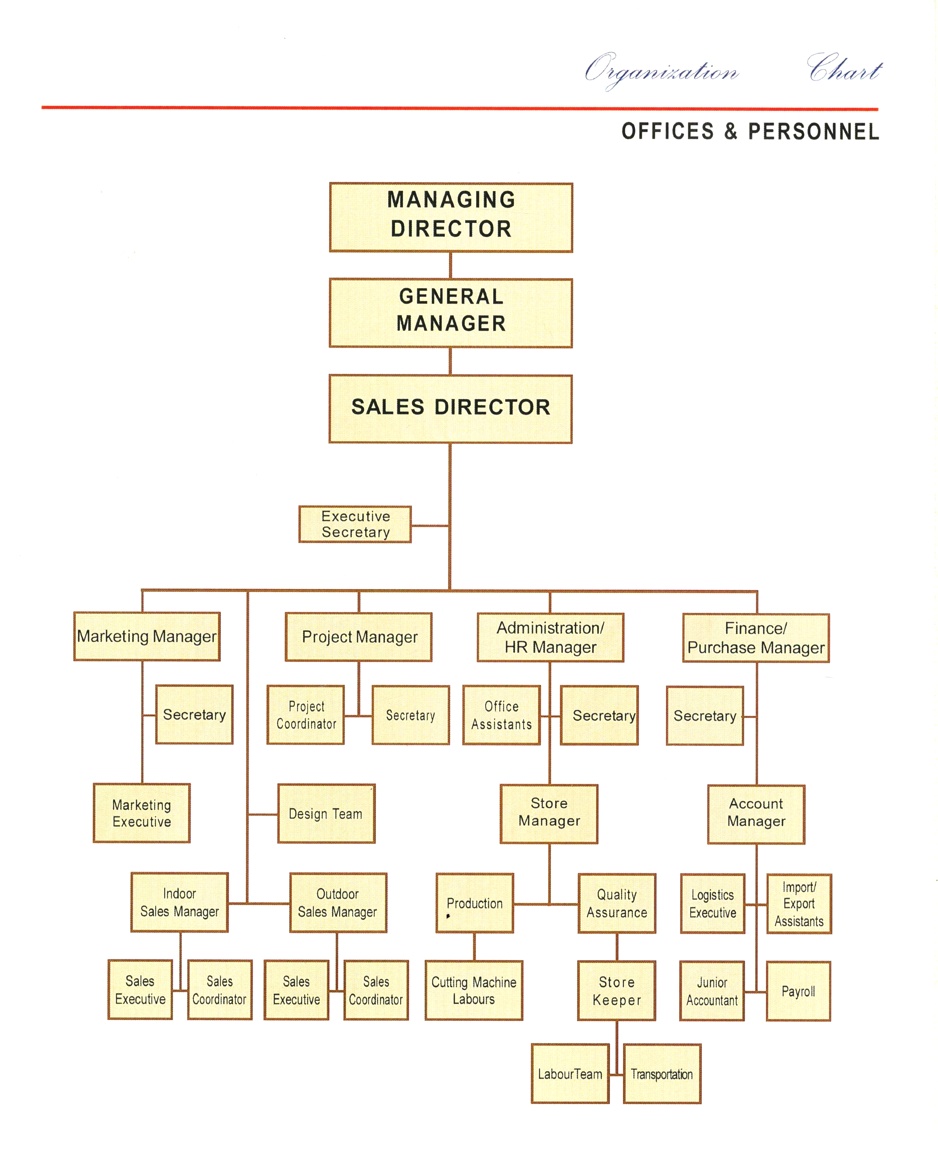

**Appendix C – Quality Assurance Dept. Organization Chart**



The QA system headed by Sales Director.

1. The technicians will conduct the material checking under the supervision of AQAO
2. Once Checking is finished, it will be reported to QAO.
3. Based on AQAO’s report and randomly witnessing the QC test, QAO will forward the same to Warehouse in Charge.
4. Ware House in Charge will directly report to Sales Director.

**Appendix D – Document Control**

1. Goods Received Note (GRN) received from QA department
2. Proforma Invoices receiving from factories
3. Order taken from Customers
4. All Invoices & Delivery Notes
5. All Correspondences Incoming/Outgoing etc.
6. QA reports
7. Machinery Reports
8. Vehicle Reports
9. Stationary Items Ordering/Purchasing
10. All HR & Admin related , Accounts file etc

**Appendix E – Flow Chart & Job Description of QC in Cutting**



Note:

1. The Technicians will conduct the QC tests
2. The QC in charge will witness the tests
3. QAO will also randomly witness the tests
4. QAO will submit the reports to Warehouse Manager.
5. Warehouse Manager will submit in turn to Sales Director
6. Sales Director will submit to Management for review.

**Appendix F – Control of Special Process – Cutting Dept.**



Control of Special Process

1. The Warehouse will issue necessary materials for Cutting to the Cutting factory.
2. After Cutting, the QA dept. will make sure that the materials have been cut as per requirement.
3. After Qc Check it will sent back to Warehouse.
4. At Warehouse, QC check will be there for Quality Assurance.
5. After QA check, the material will be delivered to Client.

**Appendix G – Procurement Flow Chart**



Process

1. First, the Sales Man will take order for the materials from client.
2. The Order will be forwarded to Logistics Dept.
3. Logistics Dept. will forward the order to factories.
4. Once material is ready at factory, will be send to Warehouse.
5. After normal procedure, the material will be delivered to site

|  |  |  |  |  |
| --- | --- | --- | --- | --- |
|  | **Safety Manual** | | | |
|  |  |  |  |

|  |  |
| --- | --- |
|  |  |

Supplier Address: **NAZO BUILDING MATERIALS TRDG.EST**

Telephone Number: **+971-6-567 1221 / +971-6-567 1511**

Approved by: **Mr. MOHD ABDEL RAZEK**

**SALES DIRECTOR**

Mr. MOHD ABDEL RAZEK \_\_\_\_\_\_\_\_\_\_\_\_\_\_\_\_\_\_\_\_\_\_\_\_\_\_\_\_\_\_ (Signature)

Prepared By: – **Mr. Gurudhath**

**The Warehouse Safety Officer**

Mr. Gurudhath \_\_\_\_\_\_\_\_\_\_\_\_\_\_\_\_\_\_\_\_\_\_\_\_\_\_\_\_\_\_ (Signature)

Submitted By: **Mr. Sandeep Kaul**

**Warehouse Manager**

Mr. Sandeep Kaul ------------------------------------------------- (Signature)

Review by: **By Management**

**SAFETY AND HEALTH MANUAL**

CHAPTER TITLE

1. INTRODUCTION TO SAFETY MANUAL

2. LEADERSHIP & COMMITMENT

3. ORGANIZATION RESOURCES & IMPLEMENTATION

4. SAFETY POLICY & OBJECTIVES

5. RISK EVALUATION

6. PLANNING STANDARD PROCEDURES TO BE FOLLOWED

7. IMPLEMENTATION & MONITORING

8. AUDIT

9. REVIEW

1. **Introduction to Safety Manual**

Employees who work in Nazo Building Materials need to be aware of risks they may encounter in order to avoid injury. Staff who may enter an active work zone face a different, and often less predictable, set of hazards. In addition to office safety, this will cover basic safety for those who are working in Warehouse and Cutting Department

1.01 PURPOSE

The purpose of this Manual is to provide information regarding health and safety in office & Warehouses as well as in the Cutting Zone for supervisors and employees who may have to perform their respective works.

1.02 POLICY STATEMENT

Managers, supervisors, and employees shall do everything reasonably possible to maintain a safe and healthy work environment in all places of employment. This applies both when an employee is in the office or any work place and when performing their assigned duties.

2.0 **The leadership & commitment**

All levels of management and supervision are responsible to ensure a safe, healthy, and secure work environment, free from violence, threats, harassment, and intimidation that may exist for employees and the public, including persons with disabilities, and that the public is protected from harm in connection with Nazo’s operations.

The Leadership persons shall have a discussion with employees, prior to beginning work, when a new job duty or process is introduced. They will instruct employees on how to recognize hazards, discuss specific procedures for avoiding injury, and discuss first aid procedures in the event of an injury. Supervisors shall document these discussions as part of the regularly scheduled safety meeting

2.1 IMPLEMENTATION

Conduct pre-job meetings with employees to discuss hazards unique to their job assignment, including the hazards associated with lifting activities, and working near Cutting Equipment’s;

Talk to employees to improve awareness of the incidence of accidents due to negligence of safety procedures at work zone

Supervisors are responsible to comply and enforce health and safety policies, procedures, regulations, laws or rules. Failure or neglect may be cause for discipline in accordance with the provisions described in the Department of Personnel Administration’s Guide to Employee Conduct and Discipline.

2.2 DOCUMENT SAFETY MEETINGS

The safety meetings to be documented for issuing to all labors for their prompt compliance

* Maintain a safe and secure work log
* Report to work mentally and physically capable to perform all assigned duties without jeopardizing the health and safety of themself, other employees, or the public
* Notify his/her supervisor of any personal medical condition or prescribed medication which might impair their ability to perform assigned duties;
* Maintain accessible records on health and safety matters

2.3 ROUTING SAFETY MEETING REPORTS

Upon completion of the safety meeting, the first-supervisor shall follow the Action and Distribution section of form:

* + Completing and signing form;
  + Retaining and posting one copy;
  + Sending original to second-line supervisor for review;
  + Posting a copy of the completed report in a conspicuous place near the work area for employees to read. The posted copy should be replaced by that from the next scheduled safety meeting.
  + Investigate and document all injuries, illnesses, and actual or alleged acts of workplace violence to identify contributing factors and prevent further occurrences.

3. **Organizational Resources and Implementation**

1. The SALES DIRECTOR – Mr. Mohd Abdel Razek is responsible for:

* Promoting health and safety policies, procedures, and work practices through effective planning;
* Providing program direction through Head Office and Branch Offices, Warehouse & Cutting Department
* Ensure that health and safety issues are routinely discussed by all levels of management at staff meetings (or other appropriate meetings)
* Ensure that all employees receive training to cover hazards basic to all places of employment, and specific training to cover hazards unique to individual job assignments
* Enforce all health and safety laws, rules, and policies, and initiate corrective action for employees who violate health and safety laws, rules, and policies;

2. The Warehouse Manager – Mr. Sandeep Kaul is responsible for:

* Direct their Supervisors, and laborers to comply with all elements of the Safety System
* Enforce all health and safety policies, procedures, and work practices through appropriate counsel, education, and discipline
* Assess health and safety program policy issues and review the effectiveness of the Department's Health and Safety program
* Establish, if necessary, a Health and Safety liaison staff to coordinate their programs with the Head Office of Health and Safety;
* Develop, adopt, and publish health and safety policies and procedures, if necessary, to fit operational needs that are consistent with the UAE regulations.

3. The Warehouse Safety Officer – Mr. Gurudhath is responsible for:

* + Direct their supervisors, and employees to comply with all elements of the Safety aspects;
  + Enforce all health and safety policies and procedures through appropriate counsel, education, and discipline
  + Assess health and safety program policy issues and analyze the effectiveness of the Department's Health and Safety program
  + Ensure that health and safety issues are routinely discussed by all levels of management at staff meetings;

4. The Cutting Factory Safety Officer – Mr. Sandesh is responsible for:

* Maintain appropriate accident prevention in Cutting Zone
* Maintain a Health and Safety Office with appropriate staff
* Develop, adopt, and publish health and safety policies and procedures to fit operational needs.
* Conduct safety meetings to discuss health and safety matters, workplace violence and security, specific workplace hazards, and encourage open discussions on employee concerns
* Ensure that each employee understands assigned tasks, is provided with necessary equipment, and follows all health and safety policies, procedures, and work practices
* Prohibit from work an employee who appears to be unable to perform his/her assigned task(s) in a safe manner
* Designate a responsible person-in-charge when they are away from the workplace

**4. Safety Policy & Objectives**

Nazo is following a Safety Policy to create an accident free zone work area in Offices, Warehouse and the Cutting Dept. It is the supervisor’s responsibility to communicate to employees all safety information that is necessary to complete their job duties in a safe manner. To accomplish this, the supervisor shall:

* Do everything within their control to assure a safe workplace for their employees;
* Ensure that employees are aware of and comply with departmental health and safety policy, procedures, and work practices;
* Discuss health and safety matters, the Department’s goal to “Provide the safest transportation system for users and workers,” and encourage open discussions of employee concerns, including a safe and secure work environment
* Discuss safe practices anytime it appears that an employee is not following safety policies, procedures, and work practices; and discuss health and safety issues at least annually at the time of issuing Individual Development Plans/Performance and Appraisals or probation evaluations.

The Main Objective of this safety policy to encourage a free-flow of ideas regarding improving employee safety, the supervisor should take every opportunity to exchange ideas on safety and accident prevention with employees, commend them for their efforts to perform their jobs safely, and invite employees to discuss safety suggestions. Supervisors should review and consider all employee suggestions and implement or arrange to implement them whenever possible.

If a safety suggestion is beyond the authority of the first-line supervisor, he/she should arrange to have the suggestion reviewed by a higher level supervisor for consideration and implementation.

5. **Risk Evaluation – Conduct and Document Safety Inspections**

Risk Evaluation is a mandatory requirement of the Department’s Injury and Illness Prevention Program (IIPP). Safety inspections are required at all Departments including Warehouse, Cutting Factory, Main Showrooms, and Branches etc. for evaluation. The Risk evaluation is formulated by conducting Safety Inspections on occasions.

5.1 PURPOSE

Details are provided outlining the process for conducting and documenting safety inspections. Inspections will identify and reduce safety and health hazards that could contribute to occupational injury or illness.

5.2 POLICY STATEMENT

Supervisors shall schedule, conduct, and document safety inspections in all work areas under their jurisdiction to identify and reduce physical and/or environmental hazards that could contribute to injuries or illnesses.

5.3 SAFETY INSPECTIONS FOR RISK EVALUATION

Safety inspections are classified as: (1) Informal, (2) Formal, and (3) Special.

5.3.1. INFORMAL INSPECTIONS

Informal inspections shall be performed on a continuous basis. Sales Director will conduct informal inspections when he visit a Warehouse or Cutting Zone and should be performed in cooperation with designated Safety supervisors at each location. Safety Supervisors will routinely conduct informal inspections in the workplace and should discuss the inspection process during regularly scheduled safety meetings.

In the course of normal daily activities, supervisors and employees shall visually inspect the work area to identify unsafe conditions and/or acts and initiate corrective action as deemed necessary or appropriate. Each employee should be alert to hazardous conditions that may cause an incident or illness. If a condition is discovered, the employee must take corrective action to mitigate the hazardous condition. This may include reporting the condition to a supervisor. Informal inspections can be conducted with minimum documentation, but any and all deficiencies, no matter how minor, must be documented along with the steps taken to correct the situation. Supervisors shall record the specific findings and corrective actions taken, including the dates corrections were made and/or scheduled.

5.3.2 FORMAL INSPECTIONS

Formal inspections require a walk-through of a facility or worksite for the purpose of identifying unsafe conditions and/or acts. Formal inspections must be documented. The documentation must include the specifics of an observed hazard and the dates by which the hazard will be corrected.

Formal inspections are conducted by Safety Officers in cooperation with supervisors and employees. Safety Officer should discuss inspection schedules with local supervisors prior to inspections. Inspections should be agreed upon and be conducted at times and in a manner that will minimize disruptions of scheduled work.

Formal inspections must be conducted at all fixed worksites whenever conditions warrant. Fixed worksites include all facilities.

5.3.3. SPECIAL INSPECTIONS

Special inspections are performed in response to reports of alleged unsafe acts and/or conditions or to evaluate the hazards or health risks that may be associated with existing and/or new substances, processes, procedures, or equipment. Inspection response time to these special circumstances shall be based upon the severity of the identified hazard. A special inspection may also be conducted in conjunction with an accident investigation.

Serious and/or life threatening hazards shall be acted upon immediately by the supervisor or responsible person in charge. Specific actions may include stopping a work activity or taking any other measures necessary to protect employees, the public, the facility, and/or equipment. The hazard must be corrected or the situation or unsafe condition neutralized.

For non-serious situations, a safety inspection may be conducted as soon as possible after an initial report, identification, or recognition of a hazard.

6. **Planning standard procedures to be followed**

By planning and implementing standard procedures to complete the safety hazards at work site, an accident free zone would be created at Offices and other work areas.

For all the activities like Lifting of materials in Warehouse, Cutting of materials in factory, Nazo is following some standard procedures.

Separate Method of Statements for each activity is followed at Warehouse & Cutting to avoid any hazards at work.

6.1 ACCIDENT INVESTIGATION & ANALYSIS

6.1.1 PURPOSE

The purpose is to provide information regarding accident investigation techniques and procedures. An accident is broadly defined as an undesired event that results in physical harm to a person or damage to property and/or the interruption of a process. It also includes events that result in a non-injury, a near miss, an occupational illness, or exposure to hazardous substances.

These guidelines do not provide a ready answer to accident prevention, but rather a guide to aid in accident investigations, analysis, and corrective action. Corrective action must focus on such things as eliminating unsafe conditions and correcting unsafe acts.

6.2 POLICY STATEMENT

Supervisors shall investigate, analyze, and document every vehicle accident, occupational injury and/or illness, and all near miss occurrences. The investigation should be conducted in a timely manner to identify contributing factors that will prevent further incidents. When possible, the investigation should be initiated within 24 hours and completed within 72 hours of the accident.

6.3 ACCIDENT INVESTIGATIONS

Investigating and documenting occupational injuries and illnesses is a mandatory requirement of Approved Code of Practice in UAE

First Line Supervisor

The first-line supervisor investigates all accidents in accordance with departmental policy. The first-line supervisor is typically on the scene and thus would have more knowledge regarding the accident and accident scene.

SECOND-LINE SUPERVISOR

The second-line supervisor ensures that the first-line supervisor conducts the accident investigation and reviews the first-line supervisor’s findings. The reviewing supervisor shall follow-up with the first-line supervisor to ensure that all corrective measures have been taken to avoid further accidents.

SAFETY SPECIALIST

The Safety Specialist advises and/or assists in the investigative effort. Safety Specialist representatives should have specialized training and experience that enables them to determine the facts, apparent and hidden. Safety Specialists are impartial and their primary interest is to gather information that can be used to prevent future similar accidents as well as identify policy and regulation violations and suggest corrective measures.

6.4 ACCIDENT SCENE INVESTIGATION

Investigation of accidents should be conducted as soon as possible. Any delay may result in evidence being altered, destroyed or removed.

The purpose of a documented review of the accident scene is to:

* + Identify and locate the physical evidence (materials/machines/tools) involved in the accident;
  + Reveal deficiencies in operating policies, processes and procedures; and
  + Discover unsafe work practices caused by a lack of training.

The purpose of an accident investigation is to find facts not assign fault. The facts will then serve as a guide to the conditions that caused the accident. The facts should identify the "why" or root cause of the accident as well as the "who, what, when, where, and how.”

Fact-finding assists the investigators to expand their thinking and not focus solely on the type of accident or the injury. A broader view of the facts surrounding the accident will help point to contributing factors that lead to the root cause. This expanded view also assists investigators to identify a variety of preventive measures that may be used to correct future similar situations or conditions.

6.5 EQUIPMENT CHARACTERISTICS

Describe the type, brand/model/size and any distinguishing features/condition/specific part of the equipment involved (include the identification number, and any known modifications that may have been made to the equipment).

6.6 CORRECTIVE ACTION

For corrective action to take place, the investigator must present facts that show the incident would not have happened if an event had not taken place. To do this, the investigator must first reach a basic understanding of events and the sequence in which they occurred. The following factors should be analyzed:

6.7 MACHINES

Hazardous conditions/construction/design and Equipment, tools, and objects.

PHYSICAL WORK ENVIRONMENT: Location of equipment, tools, and objects in the workplace. Location of employees in the work spaces

7. **Implementation and monitoring**

INTRODUCTION

Employees who work in an office environment need to be aware of risks they may encounter in order to avoid injury. All the safety standards which are to be followed at wok zone to be properly implemented by conducting Toolbox meetings, by Circulars, by posters, by direct meetings etc. In addition to office safety, Warehouse safety & Cutting zone safety to be strictly followed.

PURPOSE

This chapter provides information regarding health and safety in office settings and instructions for supervisors and employees who may have to perform fieldwork.

POLICY STATEMENT

Managers, supervisors, and employees shall do everything reasonably possible to maintain a safe and healthy work environment in all places of employment. This applies both when an employee is in the office and when performing other assigned duties.

BACKGROUND

The policies, practices, and standards described in this chapter are based on the Code of Practice commonly followed in UAE as approved standards

RESPONSIBILITY FOR HEALTH AND SAFETY

Supervisor

Supervisors are responsible for the health and safety of their employees and to ensure that the work environment does not contribute to injury or illness. In order to achieve this, supervisors are required to:

* Routinely conduct safety inspections and have regularly scheduled safety meetings with their employees to discuss health and safety issues;
* Enforce all health and safety policies, procedures and work practices. Whenever an employee violates a health and safety policy, law, regulation or rule, supervisors shall consider appropriate discipline
* Discuss medical or other emergency situations with their employees and emergency procedures contained in their local Emergency Action Plan;
* Maintain in their files a copy of each employee’s “Emergency Notification Information” form for emergency information purposes (see Chapter 9 for details); and
* Discuss potential hazards when an employee leaves his/her office to participate in a field trip.

Employee

Employees are responsible to do everything reasonably necessary to protect their own health and safety and that of others by complying with all occupational health and safety policies, procedures, laws, rules and/or regulations. To achieve this, employees are required to:

* Report to work mentally and physically capable of performing all of their assigned duties without jeopardizing the health and safety of themselves, other employees, or the public;
* Be free from the effects of medication, controlled substances, alcohol or the complications arising from illness or injury that might impair their judgement and/or ability to perform their work;
* Promptly report all injuries, illnesses, or unsafe conditions to their supervisor; and
* Inform their supervisor of any changes in home address, medical condition, name of a family member or designated person to contact following an emergency, choice of predesignated personal physician, and advise their supervisor if they will need assistance during an emergency evacuation.

LIFTING OF EQUIPMENT, SUPPLIES, AND OTHER ITEMS

There are no written standards to control the amount of weight that a person can lift without causing injury. Whenever any object is to be lifted, some discretion or judgment must be used. Employees should never lift anything that may cause injury. Always ask for assistance.

Inspect storage boxes, supplies, or containers with unknown or heavy contents before attempting to lift using proper lifting techniques

ELECTRICAL SAFETY

Office work areas are subject to the OSHA Electrical Safety Orders (ESO). The following represents some pertinent electrical safety standards:

* Electrical power cords for computers, printers, or other electrical devices shall not be placed on the floor unprotected or where they may create a tripping hazard;
* Electrical extension cords are permitted, but shall not be used as a substitute for fixed wiring. Where possible, new electrical outlets should be installed to eliminate the need to use extension cords.
* When a telephone or electrical box on the floor is exposed, the box should be marked as a hazard until the hazard is removed.
* Office supplies should be stored in appropriate areas set aside for that purpose, and not where they could contribute to injury.

Do not:

* Store materials on top of modular furniture, overheads or cabinets;
* Store materials above the level of your shoulders;
* Place objects such as flower pots and vases on windowsills or ledges;
* Place card index files, dictionaries, or other heavy objects on top of file
* cabinets taller than five (5) feet;
* Use storage boxes (cardboard boxes) as room dividers; and/or
* Use walkways, hallways, stairwells and/or landings for storage.

Walkways and hallways should be maintained free of all obstructions or impediments for use in case of an emergency.

STAIRWAYS

All stair tread surfaces shall be slip-resistant. Stairways shall be maintained in good repair having handrails on each side. Stairways shall not be used as storage areas and must be kept free of tripping hazards.

EXIT/DIRECTIONAL SIGNS

Exit signs, directional signs, or both, shall be provided at every exit door, at the intersection of corridors, at exit stairways or ramps, and at other locations as necessary to inform occupants of the means of egress available.

Electrically illuminated exit signs shall be lighted with at least two electric lamps. Burnt out electric lamps shall be replaced in a timely manner.

HEARING PROTECTION

The Department’s Hearing Protection Program (HPP) is designed to protect employees from hearing loss through the introduction of engineering controls, implementation of administrative controls, or through the use of personal protective equipment (PPE).

Provide ear plugs and/or ear muffs and make available as needed a variety of suitable hearing protection equipment to employees;

**8. Audit**

Auditing for the Safety Manual depends on the inspections made at work places from time to time.

Special inspections are conducted by Sales Director upon request and in cooperation with local supervisors and employees.

Special inspections must be documented. The documentation must include specific identification of observed hazards and the dates by which the hazards will be corrected. Follow-up procedures must be performed to assure that the identified hazards are mitigated in a timely manner.

**9. Review**

The Safety Manual is prepared after required Revisions from the Management view.

Timely review for the same will be after one year from the Safety Manual Date.

The review will be as per the requirements from Management from time to time, which will be coordinated together with the suggestions from employees, Safety Offices etc. and all put together will constitute the proper review annually.